Athens County
Coordinated Transportation Plan
2022-2026
Lead Agency: Athens County Board of County Commissioners
For more information about this plan please contact Bryan Hinkle, Athens-Hocking County Mobility Coordinator at 740-767-4500 or bryan.hinkle@hapcap.org
Funding for the development of this plan was provided by the Ohio Department of Transportation

Table of contents
Contents
Executive Summary 3
I. Geographic Area 5
II. Population Demographics 12
III. Assessment of Available Services 17
Existing Transportation Services 18
List of Transportation Service Providers 18
IV. Assessment of Community Support for Transit 57
Safety 59
Vehicles 60
Summary of Existing Resources 67
V. Assessment of Transportation Needs and Gaps 67
Local Demographic and Socio-Economic Data 68
Analysis of Demographic Data 71
General Public and Stakeholder Meetings/Focus Groups 71
Surveys 72
Athens County Transportation Survey for the General Public 72
Notable Comments 75
Notable Comments 76
Final Insights and Analysis of Data: General Population Survey 77
Athens County Transportation Survey for Individuals Age 60+ 78
Notable Comments 81
Notable Comments 81
Final Insights and Analysis of Data: Individuals Age 60+ 82
Athens County Transportation Survey for Individuals with Disabilities 82
Notable Comments 86
Final Insights and Analysis of Data: Individuals with Disabilities 86
Athens County Transportation Survey for Social Services and Non-Profits 87
Notable Comments: 90
Final Insights and Analysis of Data: Social Services / Non-Profit Survey 90
Athens County Transportation Survey for Transportation Providers 90
Notable Comments: 95
Notable Comments: 95
Final Insights and Analysis of Data: Transportation Providers 96
Athens County Transportation Survey for Businesses 96
Notable Comments: 98
Final Insights and Analysis of Data: Businesses 98
Athens County Express Transportation Survey 99
Notable Comments 99
Final Insights and Analysis of Data: Express 99
Challenges to Coordinated Transportation 100
Summary of Unmet Mobility Needs 101
VI. Goals and Strategies 102
Developing Strategies to Address Gaps and Needs 102
Goal #1: 102
Goal #2: 103
Goal #3: 104
Goal #4: 105
Goal #5: 106
Goal #6: 107
Goal #7: 108
Goal #8: 109
Goal # 9 110
Goal #10: 111
VII. Plan Adoption 112
Appendix A: List of Planning Committee Participants 113
Agency Representation 113
Appendix B: List of Annual Reviews and Plan Amendments 114
Annual Review N/A 114
Amendment N/A 114
Appendix C: Definitions 115

Executive Summary
This plan is the Public Transit-Human Services Transportation Plan for Athens County. The plan was initially developed in 2007-2008 and updated in 2013, 2017 and 2021. This plan fulfills the requirements of the Federal Transit Administration (FTA) under the Fixing America’s Surface Transportation (FAST) Act, signed into law as a reauthorization of surface transportation programs through Fiscal Year 2020. According to requirements of the FAST Act, locally developed coordinated public transit-human services transportation plans must be updated to reflect the changes established by the FAST Act legislation. The FAST Act applies new programs and rules for all Fiscal Year 2016 funds and authorizes transit programs for five (5) years.
Transportation is a critical component of the communities in Athens County. Transportation provides access to jobs, education, health care, human services and allows all community members, including older adults and people with disabilities, to live independently and engage in community life. It is the purpose of this plan for local stakeholders to work collaboratively to do the following activities:
- Identify all community resources including
- Fixed-Route public transportation systems
- Public door-to-door accessible van providers
- Senior transportation programs
- Veteran transportation programs
- Transportation Network Company services
- Inter-city transportation providers
- Taxi services
- Door-to-door transportation services
- Ride share services
- Non-Emergency Medical transportation services
- Bikeway resources
- Bike line access
- Electric Vehicle charging infrastructure
- Complete streets resources
- Accessible sidewalks
- Pedestrian and transportation safety resources

- Identify and Prioritize community transportation needs
- Expansion of transportation services throughout the county
- Additional capacity for accessible, affordable, public door-to-door transit services
- Extended morning, night, and weekend hours
- Continuation of the Athens County Mobility Management Program
- Education and outreach of services
- Coordination of services
- Higher frequency of buses on fixed-route systems
- Implementation of the Athens County Active Transportation Plan
- Expansion of existing and implementation of new bikeway networks
- Address energy and environmental concerns
- Implement lowered or free transportation fares

- Establish a clear plan for achieving shared goals

athens County will continue to coordinate efforts with all transportation providers to achieve the goals and needs as listed in this Coordinated Transportation Plan. Through partnerships and shared priorities, the county, cities, villages, residents, businesses, social service agencies, and transportation providers will work together towards achieving the goals as stated in this document. The Athens-Hocking County Mobility Management program will utilize this plan as a roadmap for future transportation initiatives throughout the county and region.
Fundamental to the Coordinated Transportation Plan process is the active and meaningful involvement of stakeholders. For projects selected for funding under the Section 5310 program, participation in planning activities must include participation and/or representation of the following, at minimum:
- Seniors;
- Individuals with disabilities;
- People with low incomes;
- Public, private and non-profit transportation providers;
- Human services providers;
- The general public;
- Social service agencies;
- Local businesses, and;
- Regional Planning organizations.
In order to ensure participation from the above groups the following stakeholder involvement activities were performed:
This plan was developed and adopted by the Athens County Coordinated Transportation Plan Planning Committee. The Athens County Coordinated Transportation Plan Planning Committee consisted of representatives from the following organizations:

- Athens City
- Athens City Disabilities Committee
- Athens County Board of Developmental Disabilities
- Athens County Children Services
- Athens County-City Health Department
- Athens County Public Libraries
- Athens County Department of Job and Family Services
- Athens County
- Buckeye Hills Regional Council
- Rural Action
- United Seniors of Athens County
- An individual with a disability
- An individual aged 60+

Additional information about the planning committee can be found in Appendix A.

Seven (7) group specific transportation surveys and an express survey were released to the public on August 11th, 2021 and remained open for responses until October 31st ,2021:

- General public
- Seniors
- Individuals with Disabilities
- Transportation Providers
- Social Service Providers / Non-Profits
- Businesses
- Express survey

The surveys were distributed widely online due to the inability to host large gatherings. The surveys were advertised in Athens County using variety social media, print, short videos, and radio ads. Physical copies of the surveys were disturbed at the following locations:
- Athens County Public Library locations
- Athens County-City Health Department
- Southeastern Ohio Food Bank Meals-on-Wheels (Athens County only)
- Southeastern Ohio Food Bank congregate sites (Athens County only)
- Hocking Athens Perry Community Action (HAPCAP) Home Energy Assistance Program (HEAP) offices

Normally public meetings are held to gather data and information but due to the COVID-19 Pandemic and hire date of the Mobility Coordinator, in person meetings to update the Coordinated Plan were unable to be held in 2021. The current Mobility Coordinator, who was hired mid-December, did reach out to stakeholders and health and human service agencies via email and phone to discuss and receive current information needed to update the Coordinated Plan.

I. Geographic Area

Map 1: Basic map of the geographic area covered by the plan
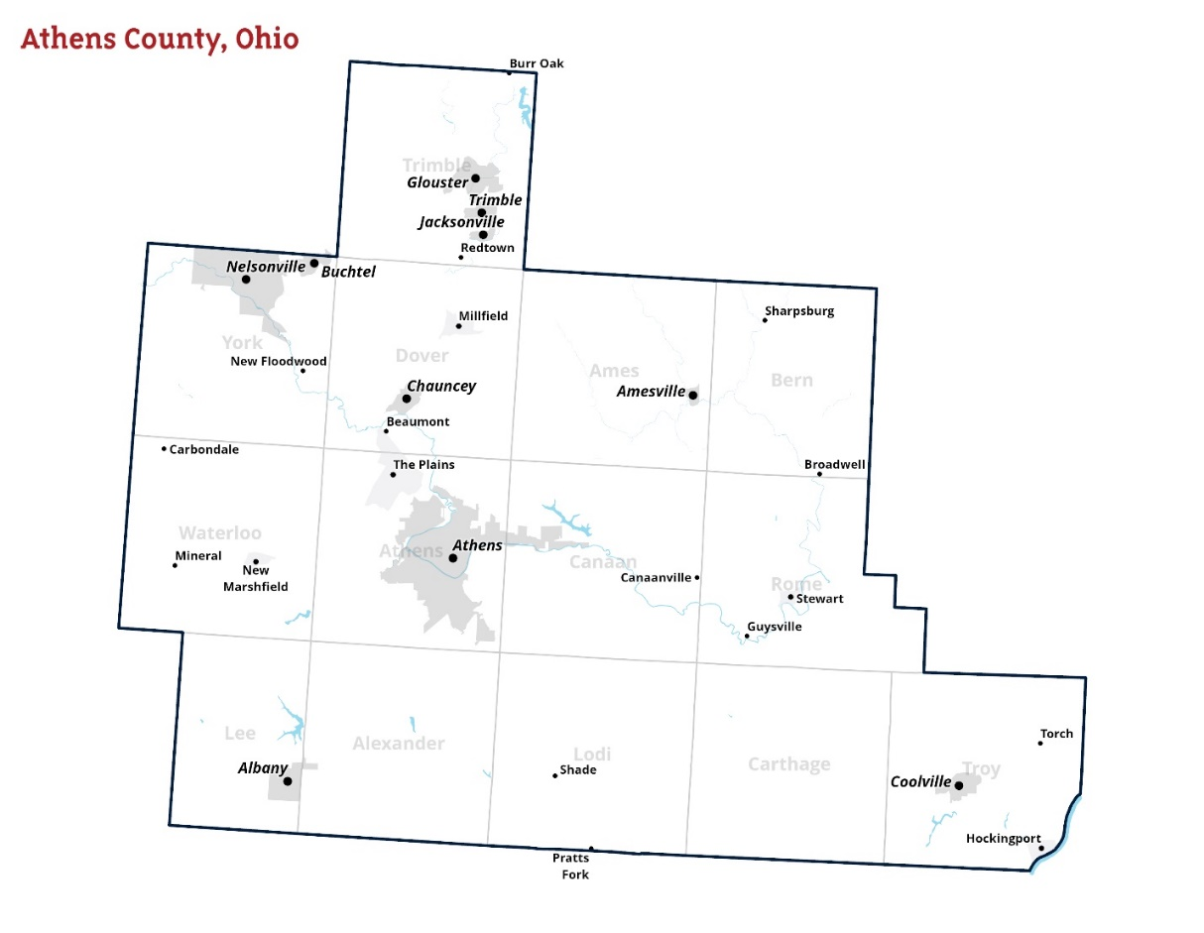

Geographically, Athens County is located in Southeastern Ohio, in the Appalachian region of the state. It has a total area of 508 square miles, of which 504 square miles is land and 4.8 square miles is water and features steep, rugged hills, deeply dissected by stream valleys.
Due to its location in the Unglaciated Allegheny Plateau region of Ohio it’s marked by steep hills and valleys in every part of the county, most dramatically on the Eastern side.
Much of Athens County is within the Hocking River watershed, with smaller areas in the Shade River and Raccoon Creek watersheds. Several streams, creeks, and rivers run through Athens County. The Southeastern section of the county makes contact with the Ohio River.
There are two cities identified:
- Athens City
- Nelsonville

The City of Athens is the largest municipality in the county and serves as the county seat.
There are eight villages identified:

- Albany
- Amesville
- Buchtel
- Chauncey
- Coolville
- Glouster
- Jacksonville
- Trimble

There are five census-designated places identified:

- Hockingport
- Millfield
- New Marshfield
- Stewart
- The Plains

There are thirty unincorporated communities:

- Beaumont
- Beebe
- Bessemer
- Big Run
- Burr Oak
- Canaanville
- Carbondale
- Doanville
- Frost
- Garden
- Glen Ebon
- Guysville
- Hamley Run
- Hartleyville
- Hebardville
- Imperial
- Kilvert
- Lottridge
- Luhrig
- Mineral
- Modoc
- New England
- New Floodwood
- Pleasanton
- Pratts Fork
- Redtown
- Shade
- Sharpsburg
- Torch
- Utley

Regionally, Athens County is bordered by:

- Perry and Morgan Counties (North)
- Meigs County (South)
- Hocking and Vinton Counties (West)
- Washington County and the Ohio River, bordering West Virginia (East)

Map 2: Map of Athens County Public Lands and Trails Systems
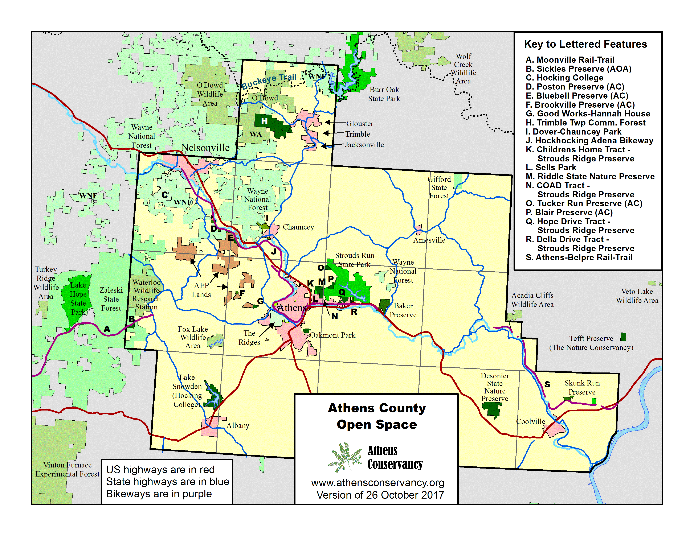
Athens County contains several federal and state lands including:

- Wayne National Forest
- Tom Jenkins Dam
- Belleville Lock and Dam Public Access Area
- Burr Oak State Park
- Strouds Run State Park
- Acadia Cliffs State Nature Preserve
- Fox Lake Wildlife Area
- Waterloo Wildlife Research Station
- Marie J. Desonier State Nature Preserve
- Riddle State Nature Preserve
- Gifford State Forest
- Waterloo State Forest
- Zaleski State Forest

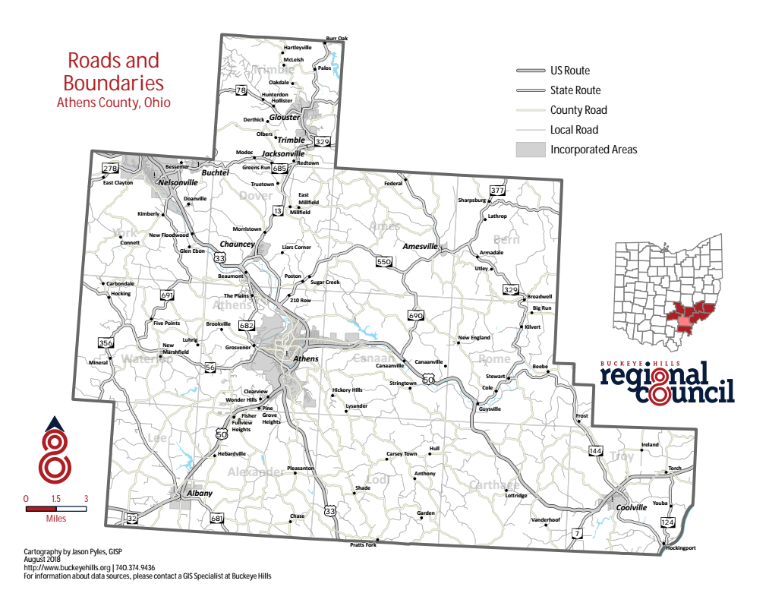
Map 3: Map of Athens County Roads and Highways
Athens County is serviced by three major highways: US33, US50, and US32.
US 33 spans from Hocking County (Northwest) to Meigs County (South) cutting through the mid-Southern region of the county. It continues on to Columbus connecting to major Interstates 70 and 71 and to Ravenswood, West Virginia connecting to I-77 and beyond.
State Route 50 and 32 extend from Vinton County (Southwest) to Washington County (Southeast). SR 50 and 32 continue onto Cincinnati to the West connecting to major Interstates 71, 74, and 75 and to Parkersburg, West Virginia connecting to Interstate 77 and beyond to the East.
Much of Athens County is serviced by county roads that connect villages such as Chauncey, Jacksonville, Trimble, Glouster, Amesville, Coolville and Albany. Often these roads contain sharp turns and hilly terrain with little lighting. Notable roads that connect the county include SR13, SR56, SR550, SR681, SR329, SR144 and SR356, some serving as the only roads connecting rural areas to major highways.

Map 4: Major trip generators in the geographic area
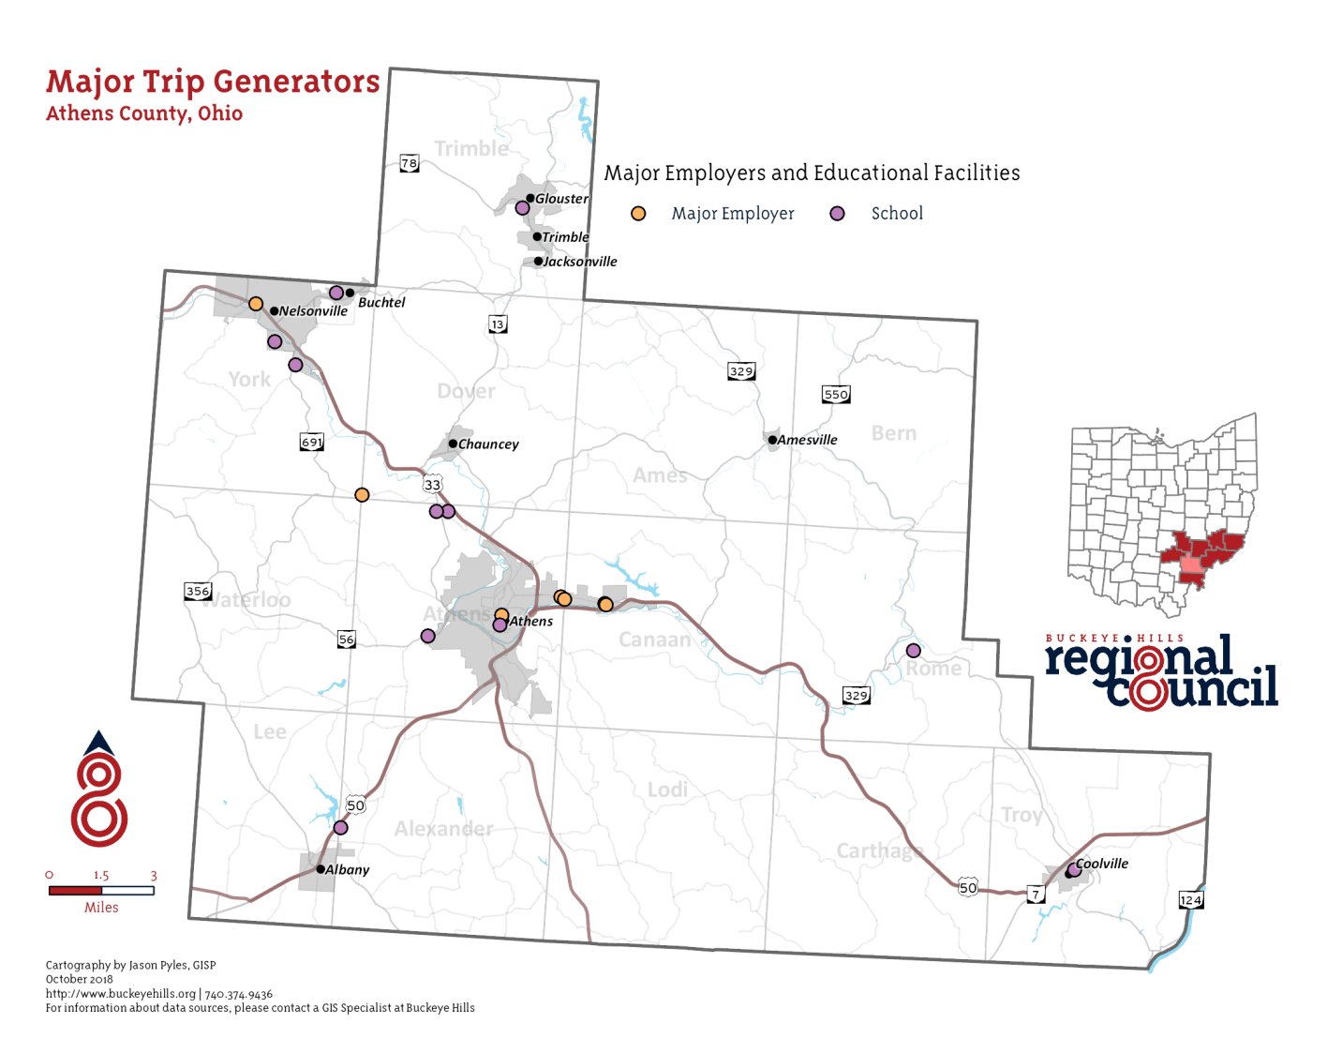
Major employers in Athens County include:

- Rocky Boots Company
- Wal-Mart Stores Inc
- Kroger
- Quidel
- Sunpower Inc
- Global Cooling
- City of Athens

Major education facilities in the county include:

- Ohio University
- Hocking College
- Tri-County Career Center
- Athens City Schools
- Federal Hocking Schools
- Alexander Schools
- Nelsonville-York Schools
- Trimble Schools
- Amesville Schools
- Coolville Schools
- Beacon School

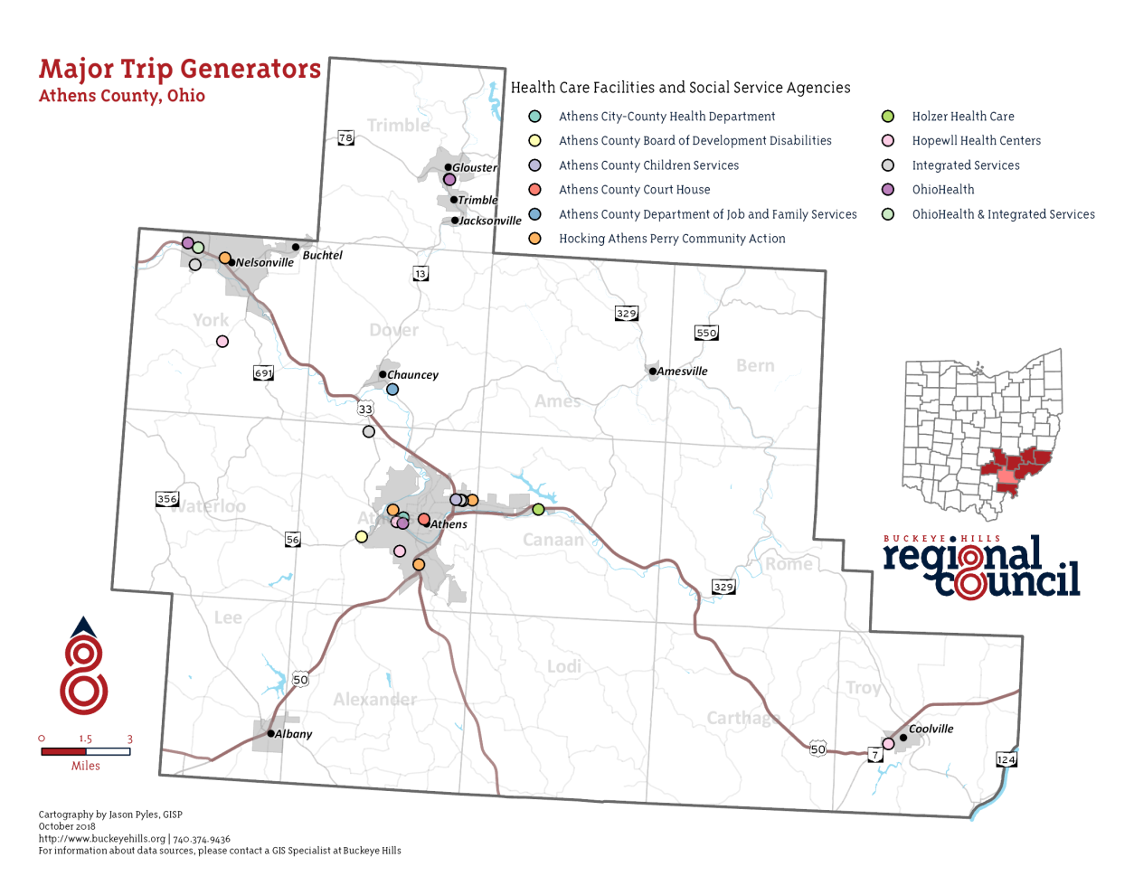
Major healthcare facilities including hospitals, mental health facilities, and urgent care branches include:

- OhioHealth
- Hopewell Health Centers
- OhioHealth & Integrated Services (Mary Hill Center)
- Integrated Services for Behavioral Health
- Athens City-County Health Department
- Holzer Health Care

Major social service agencies in the county include:

- Athens City-County Health Department
- Athens County Board of Developmental Disabilities
- Athens County Children Services
- Athens County Court House
- Athens County Department of Job and Family Services
- Hocking Athens Perry Community Action
- Integrated Services

Most major trip generators in the county are located in the city of Athens and the city of Nelsonville. In Athens City major trip generators are located mostly on East State Street, Richland Avenue, and Columbus Road. In Nelsonville they’re located close to East Canal Street, Hocking Parkway, and around Public Square in the center of town.
Major employers in the rural areas of the county are local schools, strategically spread throughout the county to ensure that all areas are covered by a close district.

II. Population Demographics
To better assess demand for transit services in Athens County, specific characteristics of the population must be examined. Due to the 2020 Census Data being incomplete at the time of this report, the 2019 estimated Census data was used. This information will be updated during our annual review. Based on 2019 estimated numbers, Athens County has an estimated total population of 65,327 individuals. Projections show a minor decline in population totals over a twenty-year period (2020-2040). Of the total population in Athens County roughly 45% reside in the City of Athens (24,984) and in the City of Nelsonville (4,769).
Chart 1: Total Population Current and Projected for Five Years
Total Population |  |  | Estimated
Census |  |  | 2014 | 64,783
1900 | 38,730 |  | 2015 | 65,886
1910 | 47,798 |  | 2016 | 66,352
1920 | 50,430 |  | 2017 | 66,503
1930 | 44,175 |  | 2018 | 65,519
1940 | 46,166 |  | 2019 | 65,327
1950 | 45,839
1960 | 46,998
1970 | 54,889 |  | Projected
1980 | 56,399 |  | 2020 | 66,720
1990 | 59,549 |  | 2030 | 66,320
2000 | 62,223 |  | 2040 | 64,830
2010 | 64,757
2016 | 66,352
2017 | 66,503
2018 | 65,519
2019 | 65,327
2020 | 66,720
2030 | 66,320
2040 | 61,960
U.S. Census Bureau (2019).
Population 2014-2019 ACS 5-year estimate

Chart 2: Total Population by Age Group
The average age of the population of Athens County is 30.5 years old with a majority (27.5%) falling in the 20 to 34-year-old category. Currently, there are an estimated 10,514 individuals aged 45 to 64 years old and 8,809 aged 65 years or more.
Population by Age |  | Number | Percent
ACS Total Population |  | 65,327 | 100.0%
Under 5 years |  | 2,906 | 4.4%
5 to 19 years |  | 15,415 | 23.6%
20 to 34 years |  | 17,948 | 27.5%
35 to 49 years |  | 9,735 | 14.9%
50 to 64 years |  | 10,514 | 16.1%
65 years and more |  | 8,809 | 13.5%
Median Age |  | 30.5
*S0101 AGE AND SEX
2019 ACS 1-Year Estimates

Chart 3: Total Population by Race
89.7% of Athens County identifies as white. 8.4% of the population identifies as one or more of the following:
Population by Race |  | Number | Percentage
ACS Total Population |  | 65,327 | 100.0%
White |  | 58,603 | 89.7%
African-American |  | 1,879 | 2.9%
Native American |  | 582 | 0.9%
Asian |  | 1,732 | 2.7%
Pacific Islander |  | 0 | 0.0%
Other |  | 0 | 0.0%
Two or More Races |  | 1,266 | 1.9%
Hispanic (may be of any race) |  | 1,265 | 1.9%
TOTAL MINORITY |  | 6,724 | 10.3%
*DP05 DEMOGRAPHIC AND HOSING ESTIMATES
2019 ACS 1-Year Estimates

Chart 4: Number and percentage of people with disabilities
Of the total estimated population 65,327 approximately 9,337 (14.4%) individuals identify with having a disability. A majority of those individuals are in the age range of 18 to 34 years old. The most common disability types identified are individuals with cognitive difficulty and ambulatory difficulty.
 | Total Population |  | With a disability | Percent with a disability
Total | 64,644 |  | 9,337 | 14.44%
Male | 31,640 |  | 4,275 | 13.51%
Female | 33,004 |  | 5,062 | 15.34%
Age with a disability
Under 5 years | 2,906 |  | 0
5 to 17 years | 7,121 |  | 973
18 to 34 years | 25,973 |  | 1,906
35 to 64 years | 20,030 |  | 3,732
65 to 74 years | 5,212 |  | 874
75 years and over | 3,402 |  | 1,852
Disability Type
With a hearing difficulty | 2,484
With vision difficulty | 1,793
With cognitive difficulty | 4,301
With an ambulatory difficulty | 3,737
With a self-care difficulty | 1,308
With an independent living difficulty | 2,777
*S1810 DISABILITY CHARACTERISTICS
2019 ACS 1-Year Estimate

Chart 5: Number and percentage of households with incomes below the federal poverty level
Poverty Status of Families by
Family Type by Presence
of Related Children |  |  | Number | Percent
Total Families |  |  | 12,169 | 100%
Family Income Below Poverty Level |  |  | 2116 | 17.4%
Married-couple families
with own children |  |  | 404 | 19.1%
Male householder, no wife
present, with own children |  |  | 359 | 17.0%
Female householder, no husband
present, with own children |  |  | 650 | 30.7%
Families with no own children |  |  | 703 | 33.2%
*Ohio County Profiles
Prepared by The Office of Research

Chart 6: Number and percentage of individuals with incomes below the federal poverty level
Athens County is considered to be the poorest county in the state with a large percentage of the population living at or below the 200% Federal Poverty Guidelines:
 | Total | Below poverty level | Percent below poverty level
 | 55,673 | 15,275 | 27.4%
AGE
Under 18 years | 9,925 | 2,899 | 29.2%
18-34 years | 17,104 | 8,338 | 48.7%
35-64 years | 20,030 | 3,661 | 18.3%
65 years and over | 8,614 | 377 | 4.4%
SEX
Male | 27,873 | 9,227 | 33.1%
Female | 27,480 | 9,036 | 32.9%

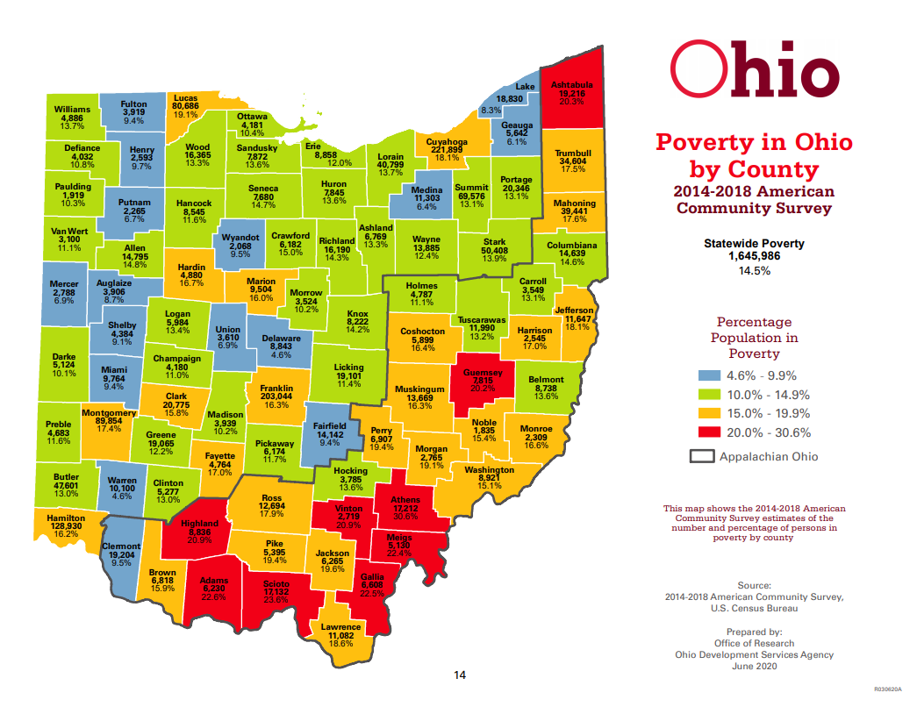
THE OHIO POVERY REPORT 2020
Prepared by The Office of Research

Chart 7: Percent of population that speak English “Less than very well”
English is spoken by a majority of residents in Athens County with close to 5% of the population speaking English less than “very well”. Due to 2020 updated census data being unavailable at the time of this plan the last 5-year ACS estimates are being utilized.
Language Spoken at Home |  | Total | Percent
Population 5 years and over |  | 62,316
English Only |  | 58,830 | 94.40%
Language other than English |  | 3,486 | 5.60%
Speak English less than "very well" |  | 1,162 | 1.90%
Spanish |  | 646 | 1.00%
Speak English less than "very well" |  | 130 | 0.20%
Other Indo-European languages |  | 743 | 1.20%
Speak English less than "very well" |  | 101 | 0.20%
Asian and Pacific Islander languages |  | 1,545 | 2.50%
Speak English less than "very well" |  | 720 | 1.20%
Other Languages |  | 552 | 0.90%
Speak English less than "very well" |  | 211 | 0.30%
*DP02 SELECTED SOCAIL CHARACTERISTICS IN THE UNITED STATES
2011-2015 American Community Survey 5-Year Estimate

III. Assessment of Available Services
Conducting an evaluation of service provider capabilities and analyzing the existing gaps and duplications of services for transportation resources in each community, provides transportation planners with the information needed to implement changes that will improve the network of transportation resources and services in Athens county and across county lines.
The lead agency identified stakeholders to participate in the assessment of available services. These stakeholders included those who were represented in the current or past planning committees, as well as others who the planning committee identified as being appropriate stakeholders.
Interviews were conducted with each of the identified stakeholders.
The purpose of the interview was to offer the stakeholders an opportunity to discuss the specific transportation services, gaps, needs, and priorities for their respective service areas or communities.
When applicable, information reported in the previous coordinated plan was used to supplement information gathered during this planning effort.

COVID-19 PANDEMIC UPDATES
Due to the COVID-19 pandemic many transportation provider’s services have been greatly impacted. Fares, operation days and times, and contract services may differ from those listed in this document as the situation is ever evolving. For questions regarding services that may have changed or discontinued please contact providers directly or contract the Athens-Hocking Mobility Coordinator, Bryan Hinkle at bryan.hinkle@hapacap.org.

Existing Transportation Services
The following information is based on tabulations from the survey and interview results. A total of 46 organizations provided information about their services.

List of Transportation Service Providers
1. Agency Name: Alexander School District
Transportation Service Type: Fixed-route school transportation

Other Services Provided: None
Contact Information: 740-698-8831
Hours: Based on school hours
Service Area: Ohio
Eligibility Requirements: Only available for students and staff
Web-site: www.alexanderschools.org

2. Agency Name: Area Agency on Aging
Transportation Service Type: Provides transportation waivers and transportation referrals. Manages the PASSPORT Program.
Other Services Provided: None
Contact Information: 1-800-331-2644
Hours: 24/7
Service Area: Ohio
Eligibility Requirements: Seniors and Medicaid recipients
Web-site: www.buckeyehills.org/aging/

3. Agency Name: Athens City-County Health Department
Transportation Service Type: Provides waivers, vouchers, and referrals
Other Services Provided: Safety training, car seat training, Creating Healthy Communities
Contact Information: 740-592-4431
Hours: Monday – Friday, 8am – 4pm
Service Area: Athens County
Eligibility Requirements: None, open to the public
Web-site: www.athenspublichealth.org

4. Agency Name: Athens City School District
Transportation Service Type: Fixed-route school transportation
Other Services Provided: None
Contact Information: 740-797-4128
Hours: Based on school hours and events
Service Area: Ohio
Eligibility Requirements: Only available for students and staff
Web-site: www.athenscsd.org

5. Agency Name: Athens County Board of Developmental Disabilities – Beacon School
Transportation Service Type: Fixed-route school transportation
Other Services Provided: Referrals, vouchers, public transit tickets
Contact Information: 740-594-3539
Hours: Based on school hours and events
Service Area: Athens County
Eligibility Requirements: Only available for students and staff
Web-site: www.athenscbdd.org

6. Agency Name: Athens County Children Services
Transportation Service Type: Door-to-door
Other Services Provided: Vouchers, public transit tickets
Contact Information: 740-592-3061
Hours: Dependent on need and funding
Service Area: Ohio
Eligibility Requirements: Only available for agency clients
Web-site: www.athenschildrenservices.com

7. Agency Name: Athens County Department of Job and Family Services
Transportation Service Type: Medicaid transportation, door-to-door
Other Services Provided: Gas vouchers, purchasing services
Contact Information: 740-677-4206
Hours: Based on appointments
Service Area: Ohio
Eligibility Requirements: Must qualify under Job and Family Services guidelines
Web-site: http://www.jfs.athensoh.org/county_services/transportation_services.php

8. Agency Name: Athens County Head Start (Hocking Athens Perry Community Action)
Transportation Service Type: Fixed-route school transportation
Other Services Provided: Free car seat program
Contact Information: 740-592-1124
Hours: Based on school hours and events
Service Area: Athens County
Eligibility Requirements: Only available for students and staff
Web-site: https://hapcap.org/child-development/head-start/

9. Agency Name: Athens County Re-Entry / Ohio Means Jobs (Athens County Department of Job and Family Services)
Transportation Service Type: Purchases transportation from other providers, provides vouchers, bus passes and tickets
Other Services Provided: Referral and training services
Contact Information: 740-797-1405
Hours: Monday – Friday 8:00am to 4:00pm
Service Area: Athens County
Eligibility Requirements: Only available for qualifying community members
Web-site: http://www.jfs.athensoh.org/county_services/reentry_services/reentry_program.php

10. Agency Name: Athens Go-To Cab
Transportation Service Type: Taxi service, door-to-door, contract services
Other Services Provided: None
Contact Information: 740-594-8294
Hours: 24/7
Service Area: Ohio
Eligibility Requirements: None, open to the public
Web-site: www.athensgotocab.com

11. Agency Name: Athens-Hocking Mobility Management Program (Hocking Athens Perry Community Action)
Transportation Service Type: Provides referrals, outreach, and travel training
Other Services Provided: Advocacy for transportation
Contact Information: 740-594-8499
Hours: Monday – Friday, 8:00am to 4:00pm
Service Area: Ohio
Eligibility Requirements: None, open to the public
Web-site: www.athensmobility.com

12. Agency Name: Athens on Demand Transit (Hocking Athens Perry Community Action)
Transportation Service Type: Door-to-door
Other Services Provided: Para-transit service for Athens Public Transit
Contact Information: 740-597-2404
Hours: Monday – Friday, 7:30am – 8:30pm, Saturday 9:00am – 4:00pm
Service Area: Athens County
Eligibility Requirements: None, open to the public
Web-site: https://hapcap.org/transportation/athens-on-demand/

13. Agency Name: Athens Public Transit (Hocking Athens Perry Community Action)
Transportation Service Type: Fixed-route system
Other Services Provided: Para-transit service, Bobcat pass, apartment complex transportation
Contact Information: 740-594-2424
Hours: Monday – Friday, 7am-10pm (depending on the bus line) Saturday, 8:45am-10pm (depending on the bus line)
Service Area: Athens City, The Plains, Chauncey, Nelsonville, Albany
Eligibility Requirements: None, open to the public
Web-site: www.athenstransit.org

14. Agency Name: Athens Veterans Association
Transportation Service Type: Door-to-door
Other Services Provided: Vouchers, referrals
Contact Information: 740-773-1141
Hours: Monday –Friday 8am-5pm
Service Area: State of Ohio
Eligibility Requirements: Only for veterans who qualify financially
Web-site: N/A

15. Agency Name: Athens Veterans Services
Transportation Service Type: Provides transportation referrals, purchases transportation
Other Services Provided: None
Contact Information: 740-592-3216
Hours: Monday –Friday 8am-5pm
Service Area: Athens County
Eligibility Requirements: Only for veterans who qualify financially
Web-site: https://www.athensveteransservicesoh.org/transportation-rsvp

16. Agency Name: The Athens Village
Transportation Service Type: Provides vouchers and referrals, contracts with providers
Other Services Provided: None
Contact Information: 740-447-0500
Hours: 24/7
Service Area: Athens County
Eligibility Requirements: Must be a member and a senior
Web-site: http://theathensvillage.org/

17. Agency Name: Buckeye Hills Regional Council
Transportation Service Type: Provides waivers, vouchers, and referrals, Passport Program
Other Services Provided: Regional transportation planning
Contact Information: 1-800-331-2644
Hours: Monday – Friday 8am-4:30pm
Service Area: Athens, Hocking, Meigs, Monroe, Morgan, Noble, Perry, Washington counties
Eligibility Requirements: None, open to the public
Web-site: www.buckeyehills.org

18. Agency Name: Daybreak Transportation Services LLC
Transportation Service Type: Door-to-door, ambulette services, bariatric vehicles
Other Services Provided: None
Contact Information: 740-401-9285
Hours: Based on appointments
Service Area: Ohio
Eligibility Requirements: None, open to the public
Web-site: www.daybreakambulette.com

19. Agency Name: Echoing Connections
Transportation Service Type: Door-to-door
Other Services Provided: None
Contact Information: 740-327-2311
Hours: Based on events and appointments
Service Area: Ohio
Eligibility Requirements: Only available for agency clients
Web-site: www.ehvi.org/adult-day-services/echoing-connections-of-southeast-ohio

20. Agency Name: Federal-Hocking School District
Transportation Service Type: Fixed-route student transportation
Other Services Provided: None
Contact Information: 740-662-6691
Hours: Dependent on school hours
Service Area: Ohio
Eligibility Requirements: Only available for students and staff
Web-site: www.fedhock.com

21. Agency Name: GoBus (Hocking Athens Perry Community Action)
Transportation Service Type: Inter-City bus
Other Services Provided: None
Contact Information: 1-888-95-GOBUS
Hours: Hours vary
Service Area: Ohio
Eligibility Requirements: None, open to the public
Web-site: www.ridegobus.com

22. Agency Name: Good Works
Transportation Service Type: Provides vouchers and purchasing transportation from other providers
Other Services Provided: Car ownership assistance via volunteer hours
Contact Information: 740-541-0816
Hours: N/A
Service Area: Athens County
Eligibility Requirements: Only available for agency clients
Web-site: www.good-work.net

23. Agency Name: Green Cab
Transportation Service Type: Taxi service, ambulette service
Other Services Provided: Medicaid transportation services, DD waivers, passport
Contact Information: 740-594-7339
Hours: 24/7
Service Area: Ohio
Eligibility Requirements: None, open to public
Web-site: https://www.facebook.com/AthensGreenCab/

24. Agency Name: HAVAR
Transportation Service Type: Door-to-door
Other Services Provided: None
Contact Information: 740-594-3433
Hours: Monday – Friday 7:30am-7:30pm
Service Area: Athens County
Eligibility Requirements: Only available for agency clients
Web-site: www.havar.org

25. Agency Name: Hocking College
Transportation Service Type: Transportation for students
Other Services Provided: None
Contact Information: 740-753-3591
Hours: Dependent on events
Service Area: Ohio
Eligibility Requirements: Only available to students and staff
Web-site: www.hocking.edu

26. Agency Name: Holzer Hospital (Athens County)
Transportation Service Type: Provides referrals to transportation providers
Other Services Provided: None
Contact Information: 740-589-3100
Hours: 24/7
Service Area: N/A
Eligibility Requirements: Only available to agency clients
Web-site: www.holzer.org

27. Agency Name: Hopewell Health Centers (Athens County)
Transportation Service Type: Medical transportation, provides vouchers, transit training
Other Services Provided: None
Contact Information: 740-592-3091
Hours: Dependent on appointments and need
Service Area: Athens, Hocking, and Vinton counties
Eligibility Requirements: Only available to agency clients
Web-site: www.hopewellhealth.org

28. Agency Name: Integrated Services
Transportation Service Type: Door-to-door, provides referrals to transportation providers and voucher programs
Other Services Provided: None
Contact Information: 740-594-6807
Hours: Dependent on need
Service Area: Ohio
Eligibility Requirements: Only available for agency clients
Web-site: www.integratedservice.org

29. Agency Name: The Laurels of Athens
Transportation Service Type: Door-to-door transportation
Other Services Provided: None
Contact Information: 740-592-1000
Hours: 24/7
Service Area: Ohio
Eligibility Requirements: Only available to residents
Web-site: https://www.laurelsofathens.com/

30. Agency Name: The Lindley Inn
Transportation Service Type: Door-to-door transportation
Other Services Provided: None
Contact Information: 740-797-9701
Hours: 24/7
Service Area: Ohio
Eligibility Requirements: Only available to residents
Web-site: https://www.lindleyinnathens.com/

31. Agency Name: Lyft
Transportation Service Type: Transportation Network Company (TNC) Services
Other Services Provided: None
Contact Information: 855-865-9553
Hours: 24/7
Service Area: Ohio
Eligibility Requirements: None, open to the public
Web-site: www.lyft.com

32. Agency Name: My Sister’s Place
Transportation Service Type: Purchases services from transportation providers and provides vouchers
Other Services Provided: None
Contact Information: N/A
Hours: 24/7
Service Area: N/A
Eligibility Requirements: Only available to agency clients
Web-site: www.mspathens.org

33. Agency Name: Nelsonville-York School District
Transportation Service Type: Fixed-route student transportation
Other Services Provided: None
Contact Information: 740-753-2106
Hours: Dependent on school hours
Service Area: Ohio
Eligibility Requirements: Only available for students and staff
Web-site: http://www.nelsonvilleyork.k12.oh.us/

34. Agency Name: Ohio Health Hospitals (Athens County)
Transportation Service Type: Purchases services from providers
Other Services Provided: None
Contact Information: 740-593-1611
Hours: Dependent on day and time of services needed
Service Area: Ohio
Eligibility Requirements: None, open to the public
Web-site: www.ohiohealth.com

35. Agency Name: Ohio University
Transportation Service Type: Fixed-route, door-to-door, rental, and purchasing transportation from another provider
Other Services Provided: None
Contact Information: 740-593-1611
Hours: Dependent on service and events
Service Area: Athens City
Eligibility Requirements: Only available for students, faculty, and staff
Web-site: www.ohio.edu/transportation

36. Agency Name: Passion Works
Transportation Service Type: Provides referrals to providers
Other Services Provided: None
Contact Information: 740-592-3673
Hours: Monday-Friday 9am-5pm
Service Area: Athens City
Eligibility Requirements: Only available for program clients
Web-site: www.passionworks.org

37. Agency Name: Personnel Plus (Athens County Board of Developmental Disabilities)
Transportation Service Type: Purchases transportation from other providers, transit training
Other Services Provided: None
Contact Information: 740-592-3416
Hours: Monday-Friday 8am-4pm
Service Area: Athens County
Eligibility Requirements: Only available for program clients
Web-site: www.athenscbdd.org/services-for-adults/personnelplus/

38. Agency Name: RHDD (Residential Home for the Developmentally Disable, Inc.)
Transportation Service Type: Door-to-door
Other Services Provided: None
Contact Information: 740-452-5133
Hours: Based on appointments
Service Area: Ohio
Eligibility Requirements: Only available for agency clients
Web-site: www.hassemanmarketing.wixsite.com/rhdd

39. Agency Name: RSVP (Retired Seniors Volunteer Program) Transportation Program (Corporation for Ohio Appalachian Development)
Transportation Service Type: Volunteer Driver Service, Medicaid transportation
Other Services Provided: None
Contact Information: 740-594-8499
Hours: Based on appointments
Service Area: Ohio
Eligibility Requirements: Must qualify with Job and Family Services or under contract services
Web-site: www.coadinc.org/senior-programs/retired-senior-volunteer

40. Agency Name: Salvation Army
Transportation Service Type: Provides vouchers, referrals, and transportation assistance
Other Services Provided: None
Contact Information: 740-797-1305
Hours: 24 hours
Service Area: Athens and Meigs counties
Eligibility Requirements: Must meet eligibility requirements
Web-site: www.salvationarmyusa.org/usn/

41. Agency Name: The Sech-Kar Company
Transportation Service Type: Non-Medical Transportation and door-to-door service
Other Services Provided: None
Contact Information: 740-753-9993
Hours: Monday –Friday 6:30am-4:00pm
Service Area: Athens County
Eligibility Requirements: Only available to agency clients
Web-site: www.sechkar.com/index.html

42. Agency Name: The Summit at Coates Run Apartments
Transportation Service Type: Purchases transportation for another provider
Other Services Provided: None
Contact Information: 740-594-3030
Hours: Monday-Thursday 7:00am-9:30pm, Friday 7:00am-2:30am, Saturday 9:30pm-2:30am
Service Area: Athens City
Eligibility Requirements: None, open to the public
Web-site: www.summitatcoatesrun.com

43. Agency Name: Trimble School District
Transportation Service Type: Fixed-route student transportation
Other Services Provided: None
Contact Information: 740-767-2525
Hours: Dependent on school hours
Service Area: Ohio
Eligibility Requirements: Only available for students and staff
Web-site: http://www.trimble.k12.oh.us/

44. Agency Name: United Seniors of Athens County
Transportation Service Type: Door-to-door services
Other Services Provided: None
Contact Information: 740-594-3535
Hours: Monday – Friday 8am-4pm
Service Area: Athens County
Eligibility Requirements: Must be 60+ and pass an assessment
Web-site: www.seorf.ohiou.edu/~usac

45. Agency Name: University Commons
Transportation Service Type: Fixed-route residential transportation
Other Services Provided: None
Contact Information: 740-593-7571
Hours: Dependent on Ohio University schedules
Service Area: Athens City
Eligibility Requirements: Only available for residents
Web-site: http://www.oucommons.com/

46. Agency Name: University Courtyard Apartments
Transportation Service Type: Purchasing service from other providers
Other Services Provided: None
Contact Information: 740-249-2485
Hours: Monday – Wednesday 7:00am-10:30pm, Thursday-Friday 7:00am-3:30am, Saturday 10:30pm-3:30am
Service Area: Athens City
Eligibility Requirements: Only available for Courtyard residents
Web-site: http://www.ucourtyardathens.com/

The table below provides a summary of the characteristics of the participating transportation providers and organizations that purchase transportation on behalf of consumers.
Table 1: Organizational Characteristics
Agency Name | Directly Operates Transportation (Yes/No) | Purchases Transportation from Another Agency (if Yes, Who?) | Legal Authority (Private Non-Profit, Private For-Profit, Public Non-Profit,) | Number of Annual One-Way Passenger Trips | Average Number Trip Denials per Week | Are Vehicles Only Available for Human Service Agency Clients (Y/N)*
1. Alexander School District | Yes | No | Government Entity | X | X | Yes
2. Area Agency on Aging | No | Yes, 1st Choice Home, Athens Go-To Cab, Daybreak, Green Cab, AODT | Public Non-Profit | X | X | Yes
3. Athens City-County Health Department | No | No | Public Non-Profit | X | X | X
4. Athens City Schools | Yes | No | Public Non-Profit | X | X | Yes
5. Athens County Board of Developmental Disabilities | Yes | Yes, AODT and APT | Public Non-Profit | X | X | Yes
6. Athens County Children Services | Yes | Yes, AODT and APT | Public Non-Profit | X | X | Yes
7. Athens County Department of Job and Family Services | Yes | Yes, GreenCab, Hopewell, RSVP | Public Non-Profit | X | X | No, general public options available
8. Athens County Head Start (HAPCAP) | Yes | No | Public Non-Profit | X | X | Yes
9. Athens County Re-Entry (ACDJFS) | No | Yes, APT and AODT | Public Non-Profit | X | X | X
10. Athens Go-To Cab | Yes | No | Private For-Profit | X | X | No, open to the general public
11. Athens-Hocking Mobility Management | No | No | Public Nor-Profit | X | X | X
12. Athens on Demand Transit (HAPCAP) | Yes | No | Public Non-Profit | 12,648 | 8 | No, open to the general public
13. Athens Public Transit (HAPCAP) | Yes | No | Public Non-Profit | 98,709 | X | No, open to the general public
14. Athens Veterans Association | No | Yes, RSVP | Public Non-Profit | X | X | Yes
15. Athens Veterans Services | No | Yes, RSVP | Public Non-Profit | X | X | Yes
16. Athens Village | No | Yes, AODT | Private Non-Profit | X | X | Yes
17. Buckeye Hills Regional Council | No | Yes, 1st Choice Home, Athens Go-To Cab, Daybreak, Green Cab, AODT | Public Non-Profit | X | X | X
18. Daybreak Transportation Services LLC | Yes | No | Private For-Profit | X | X | No, open to the general public
19. Echoing Connections | Yes | No | Public Non-Profit | X | X | Yes
20. Federal Hocking School District | Yes | No | Public Non-Profit | X | X | Yes, students and staff
21. GoBus (HAPCAP) | Yes | No | Public Non-Profit | 104,906 (2019)  27,532 (2020) | X | No, open to general public
22. Good Works | No | Yes, AODT and APT | Private Non-Profit | X | X | x
23. GreenCab | Yes | No | Private For-Profit | X | X | No, open to the general public
24. HAVAR | Yes | No | Public Non-Profit | X | X | Yes
25. Hocking College | Yes | No | Public Non-Profit | X | X | Yes, students and staff
26. Holzer Hospital (Athens County) | No | Yes, AODT and APT | Public Non-Profit | X | X | X
27. Hopewell Health Centers | Yes | Yes, AODT and APT | Public Non-Profit | X | X | Yes
28. Integrated Services | No | Yes, AODT and APT | Public Non-Profit | X | X | x
29. The Laurels of Athens | Yes | No | Private For-Profit | X | X | Yes
30. The Lindley Inn | Yes | No | Private For-Profit | X | X | Yes
31. Lyft | Yes | No | Private For-Profit | X | X | No, open to general public
32. My Sister’s Place | No | Yes, AODT and APT | Public Non-Profit | X | X | X
33. Nelsonville-York School District | Yes | No | Public Non-Profit | X | X | Yes, students and staff
34. OhioHealth O’Bleness | No | Yes, AODT and APT | Public Non-Profit | X | X | X
35. Ohio University | Yes | Yes, APT | Private Non-Profit | 5259 (2020) | X | No, open to general public
36. Passion Works | No | Yes, AODT | Private Non-Profit | X | X | X
37. Personnel Plus (ACBDD) | No | Yes, AODT and APT | Public Non-Profit | X | X | X
38. RHDD | Yes | No | Public Non-Profit | X | X | Yes
39. RSVP (COAD) | Yes | No | Public Non-Profit | X | X | No, open to general public
40. Salvation Army | Yes | No | Public Non-Profit | X | X | Yes
41. The Sech-Kar Company | Yes | No | Public Non-Profit | X | X | Yes
42. The Summit Apartments | No | Yes, APT | Private For-Profit | 47,219 Fall Semester (2019)  78,394 Spring Semester (2019)  7,054 Summer Semester (2019) | X | No, open to residents and the general public
43. Trimble School District | Yes | No | Public Non-Profit | X | X | Yes
44. United Seniors of Athens County | Yes | Yes, AODT | Public Non-Profit | 511 (2020) | X | No, open to the all seniors
45. University Commons | No | Yes, APT | Private For-Profit | X | X | Yes, only residents
46. University Courtyard | No | Yes, APT | Private For-Profit | 34,246 Fall Semester (2019)  55,268 Spring Semester (2019) | X | No, open to residents and the general public

* Answering “Yes” indicates that your agency is closed door. Your agency is considered closed door if you ONLY provide transportation to your facility as a courtesy or if you ONLY serve a particular clientele that are enrolled in your agency programs (i.e. members of a sheltered workshop, or residents in a nursing home). Answering “No” indicates that your agency is open door. This means the service is open to the public or a segment of the general public defined by age, disability, or low income. For example, if an agency provides general transportation for anyone in the community who is over the age of 60, they are considered “open door”. For example, an individual who is 60 or over can request transportation to a doctor’s appointment or the grocery store regardless of their affiliation with your agency.
The participating organizations provide a wide range of transportation including fixed route, ADA paratransit, demand response, on-demand, and human service agency fixed routes. 30 of the participating organizations provide services on weekdays. 18 operate transportation on Saturdays and 9 on Sundays. Evening services after 5pm are operated by 14 organizations. The following table depicts the transportation service characteristics by agency.
Table 2: Transportation Service Characteristics
Agency Name | Mode of Service | Days & Hours of Operation | Provides Medicaid-Eligible Trips (Y/N) | Level of Passenger Assistance Provided | Training Courses Required for Drivers
1. Alexander School District | Fixed-Route  *Students Only* | M-F  Dependent on school hours and events | No | Boarding, departing, wheelchair assistance (2 trained aids) | CDL, CPR, First Aide, Blood Borne Pathogens training
2. Area Agency on Aging | Referral and contract services | Dependent on contracted provider | Yes | Dependent on contracted provider | Dependent on contracted provider
3. Athens City-County Health Department | Referral and voucher services | X | X | X | X
4. Athens City Schools | Fixed-Route  *Students Only* | M-F  Dependent on school hours and events | No | Boarding, departing, wheelchair assistance | CPR, First Aide, Blood Borne Pathogens training
5. Athens County Board of Developmental Disabilities – Beacon School | Fixed-Route  *Students Only* | M-F  Dependent on school hours and events | No | Boarding, departing, wheelchair assistance, seatbelt assistance | CPR, First Aide, Blood Borne Pathogens training
6. Athens County Children Services | Door-to-door  *Clients Only* | Dependent on need | No | X | X
7. Athens County Department of Job and Family Services | Door-to-door | Dependent on need | Yes | Boarding, departing | Vehicle operations, customer service / ADA requirements, safety
8. Athens County Head Start (HAPCAP) | Fixed-Route  *Students Only* | M-F | No | Boarding, departing, wheelchair assistance, seat belt assistance | CDL and required training annually
9. Athens County Re-Entry (ACDJFS) | Referral services | X | X | X | X
10. Athens Go-To Cab | Door-to-door | 24/7 | Yes | X | X
11. Athens-Hocking Mobility Management | Referral and transit training services | M-F  8am – 4pm | No | X | X
12. Athens on Demand Transit (HAPCAP) | Door-to-door | M-F  7:30am-8:30pm  Saturday  9am-4pm | No | Boarding, departing, wheelchair assistance, seatbelt assistance | Vehicle operations, customer service / ADA requirements, safety
13. Athens Public Transit (HAPCAP) | Fixed-Route | M-F  7am-10pm  Saturday  8:45am-10pm | No | Wheelchair assistance | Vehicle operations, customer service / ADA requirements, safety
14. Athens Veterans Association | On-demand  *Veterans Only* | Dependent on need – RSVP contract service | No | RSVP services | RSVP services
15. Athens Veterans Services | Referrals and purchases transportation | M-F  7am-4pm | X | X | X
16. Athens Village | Referrals and purchases contract services | On-demand contract service with AODT | X | X | X
17. Buckeye Hills Regional Council | Referral and purchases contract services | PASSPORT – Dependent on contracted provider | Yes | Dependent on contracted provider | Dependent on contracted provider
18. Daybreak Transportation Services LLC | Door-to-door, NEMT | M-F  8am-4:30pm  Weekends possible | No | Boarding, departing, wheelchair assistance, seatbelt assistance, drivers wait with passengers | CPR, DRIVE Training, defensive driving, on the job training
19. Echoing Connections | Door-to-Door,  NEMT | Dependent on needs and scheduled events | Yes | Boarding, departing, wheelchair assistance, seatbelt assistance, support staff, drivers wait with passengers | Wheelchair tie down training, CPR First Aid, Blood Born Pathogen, Crisis Prevention Intervention training
20. Federal Hocking School District | Fixed-route  *Students Only* | M-F  7am – 4pm | No | Boarding, departing, wheelchair assistance | CDL, CPR, First Aide, Blood Borne Pathogens training
21. GoBus (HAPCAP) | Fixed-route  Inter-city | Dependent on route  365 / year | No | Boarding, departing, wheelchair assistance, seatbelt assistance, baggage assistance | Customer service, DRIVE, Safety, Passenger assistance, Safe driving, First Aid
21-a. GoBus (HAPCAP) –Barons Bus | Fixed-route  Inter-city | 24/7 | No | Boarding, departing, wheelchair assistance, seatbelt assistance, baggage assistance | Customer service, DRIVE, Safety, Passenger assistance, Safe driving, First Aid
21-b. GoBus (HAPCAP) – Miller Transportation | Fixed-route  Inter-city | 24/7 | No | Boarding, departing, wheelchair assistance, seatbelt assistance, baggage assistance | Customer service, DRIVE, Safety, Passenger assistance, Safe driving, First Aid
22. Good Works | Referrals and purchasing transportation | X | No | X | X
23. GreenCab | Door-to-door, NEMT | Dependent on scheduling | Yes | X | X
24. HAVAR (2020) | On-Demand  *Clients only* | M-F 7:30am-7:30pm | Yes | Boarding, departing, wheelchair assistance | Vehicle operations, customer service / ADA requirements, safety
25. Hocking College (2020) | On-Demand  *Students Only* | Dependent on need /events | No | X | No
26. Holzer Hospital (Athens County) (2020) | Referral Services | 24/7 | Yes | X | X
27. Hopewell Health Centers | On-Demand  *Clients Only* | Dependent on need | Yes | X | X
28. Integrated Services | On-Demand  *Clients only* | M-F  9am-5pm | No | X | X
29. The Laurels of Athens | Door-to-door | 24/7 | No | X | X
30. The Lindley Inn | Door-to-door | 24/7 | No | X | X
31. Lyft | Ride-Share, door-to-door | 24/7  Dependent on driver availability | No | X | X
32. My Sister’s Place | Referrals and purchases transportation | X | X | X | X
33. Nelsonville-York School District | Fixed-Route  *Students only* | Dependent on school | No | Boarding, departing, wheelchair assistance | CDL, CPR, First Aide, Blood Borne Pathogens training
34. OhioHealth O’Bleness | Referrals, purchases contract services | M-F  7:30am-8:30pm  Saturday  9am-4pm | No | AODT services | AODT services
35. Ohio University – CATS | Fixed-Route – Campus Shuttle | M-F  7:30am – 5:30pm  Fall & Spring Semesters | No | Boarding, departing, wheelchair assistance | CDL (Airbrakes and Passenger Endorsements)
35-a. Ohio University – CATCAB | Door-to-door  *OU only* | M-F  7:30am – 11pm  Sat-Sun  6pm – 11pm | No | Boarding, departing, wheelchair assistance | CPR, First Aide, Blood Borne Pathogens training
35-b. Ohio University – CATS Late Night | On-demand  *OU only* | M-F  5:30pm-11pm  Sat-Sun  6pm-11pm | No | Boarding, departing | CPR, First Aid, Blood Borne Pathogens training
35-c. Ohio University – Charter Services | Door-to-door  *OU only* | Dependent on request | No | Boarding, departing, wheelchair assistance | CDL (Airbrakes and Passenger Endorsements)
36. Passion Works | Referrals | X | X | X | X
37. Personnel Plus (ACBDD) | Referrals and ticket purchasing | X | X | X | X
38. RHDD | Door-to-Door | 7 Days per Week | Yes | Boarding, departing, wheelchair assistance | QStraint tie down training, CPR First Aid, Blood Born Pathogen, Crisis Prevention Intervention training, RHDD driver training
39. RSVP (COAD) | Volunteer Ride-Share service, door-to-door | Dependent on need | Yes | Boarding, departing | Vehicle operations, customer services / ADA requirements, safety
40. Salvation Army | Door-to-door  *Clients Only* | Dependent on need | No | X | X
41. The Sech-Kar Company | On-Demand  *Clients Only* | M-F  6:30am-4pm | X | X | X
42. The Summit Apartments | Fixed-Route | M-F  7:10am – 9:30pm  Fri, Sat  9:30pm – 2:30am | No | APT Services | APT Services
43. Trimble School District | Fixed-Route  *Students Only* | Dependent on School | No | Boarding, departing, wheelchair assistance | CPR, First Aid, Blood Borne Pathogens training
44. United Seniors of Athens County | Door-to-door  *Seniors only* | M-F  8am – 4pm | No | Boarding, departing, wheelchair assistance | CPR, First Aid, Passenger assistance training including sensitivity to aging
45. University Commons | Fixed-Route | M,W,F  7:10am-9:30pm  Tu, Thurs  7:10am-9:15pm | No | Boarding, departing, wheelchair assistance | Vehicle operations, customer services / ADA requirements, safety
46. University Courtyard | Fixed-Route | M-F  7am-6pm | No | APT Services | APT Services

Transportation-related expenses and revenues also differ by organization. State and federal funding are common revenue sources for transportation operators in Athens County. The table below provides a summary of expenses and revenues for public and non-profit transportation programs.
Table 3: Transportation-Related Expenses and Revenues
Agency Name | Fare Structure | Donations Accepted (Y/N) | Number of Full-Time & Part-Time Drivers | Number of Full-Time & Part-Time Schedulers/ Dispatchers | Revenue Sources (most recent Fiscal Year) | Total Annual Transportation Expenses
1. Alexander School District | Free for students | N | X | X | State of Ohio, sales tax | X
2. Area Agency on Aging | Free for qualifying clients | N | X | X | X | X
3. Athens City-County Health Department | X | N | X | X | State and federal funding, local levy | X
4. Athens City Schools | Free for students | N | X | X | State of Ohio, sales tax, local levy | X
5. Athens County Board of Developmental Disabilities | Free for students and qualifying clients | N | 0-5 Full-time  0-5 Part-time | 1 | State of Ohio, sales tax, local levy | X
6. Athens County Children Services | Free for qualifying clients | N | 0-5 | 0-5 | State of Ohio, local tax levy | X
7. Athens County Department of Job and Family Services | Free for qualifying clients | N | X | X | X | X
8. Athens County Head Start (HAPCAP) | Free for students | N | X | X | State and federal funding | X
9. Athens County Re-Entry (ACDJFS) | X | X | X | X | X | X
10. Athens Go-To Cab | Varies by distance | N | X | X | X | X
11. Athens-Hocking Mobility Management | X | X | X | X | X | X
12. Athens on Demand Transit (HAPCAP) | $2.00 one-way $1.00 one-way seniors of individuals with disabilities | N | 3 Full-Time  7 Part-Time | 1 Full-Time | ODOT 5311 | 519,974 (2020)
13. Athens Public Transit (HAPCAP) | $1.00 one-way $.50 one-way seniors of individuals with disabilities | N | 13 Full-Time  5 Part-Time | 1 Full-Time  1 Part-Time | ODOT 5311 | 1,496,985 (2020)
14. Athens Veterans Association | Free for qualifying veterans | N | RSVP contract service | RSVP contract service | X | X
15. Athens Veterans Services | X | X | X | X | X | X
16. Athens Village | X | X | X | X | X | X
17. Buckeye Hills Regional Council – PASSPORT | Free for qualifying seniors | N | N/A, contract services | N/A, contract services | X | X
18. Daybreak Transportation Services LLC | Varies by distance | N | 0-5 Full-Time  5-10 Part-Time | 1 | X | X
19. Echoing Connections | Free for agency clients | N | X | X | X | X
20. Federal Hocking School District | Free for students | N | X | X | X | X
21. GoBus (HAPCAP) | Varies by distance | N | Contract services | Contract Services | 5311(F) | 6,081,065 (2020)
22. Good Works | X | X | X | X | X
23. GreenCab | Medicaid Only | N | X | X | X | X
24. HAVAR | Free for qualifying clients | N | X | X | X | X
25. Hocking College | Free for students and staff | N | X | 0 | X | X
26. Holzer Hospital (Athens County) | X | X | X | X | X | X
27. Hopewell Health Centers | Free for qualifying clients | N | X | X | X | X
28. Integrated Services | X | X | X | X | X | X
29. The Laurels of Athens | Free for residents of facility | N | X | X | X | X
30. The Lindley Inn | Free for residents of facility | N | X | X | X | X
31. Lyft | Based on distance and time of ride requested | N | X | X | X | X
32. My Sister’s Place | X | X | X | X | X | X
33. Nelsonville-York School District | Free for students | N | X | X | X | X
34. OhioHealth O’Bleness | X | X | X | X | X | X
35. Ohio University – CATS | Free for students, faculty and staff | N | 16-20 | 5 | X | X
35-a. Ohio University – CATCAB | Free for students, faculty, and staff | N | 16-20 | 5 | X | X
35-b. Ohio University – CATS Late Night | Free for students, faculty, and staff | N | 16-20 | 5 | X | X
35-c. Ohio University – Charter Services | Dependent on distance traveled | N | 16-20 | 5 | X | X
36. Passion Works | X | X | X | X | X | X
37. Personnel Plus (ACBDD) | X | X | X | X | X | X
38. RHDD | Free for those who qualify | N | 0-5 | 0-5 | X | X
39. RSVP (COAD) | Medicaid Only | Y | Volunteers | Volunteers | X | X
40. Salvation Army | X | X | X | X | X | X
41. The Sech-Kar Company | Free for qualifying clients | N | X | X | ACBDD | X
42. The Summit Apartments | Free for residents | N | Contract service, APT | Contract Service, APT | Contract Service, APT | Contract Service, APT
43. Trimble School District | Free for students | N | X | X | State funding | X
44. United Seniors of Athens County | Free for seniors | Y | 0-5 | 0-5 | Athens County Senior Services Levy, Older American Act – Title B3, Buckeye Hills, local grants | X
45. University Commons | Free for students | N | X | X | Apartments and fees | X
46. University Courtyard | Free for residents | N | Contract Service, APT | Contract Service, APT | Apartments and Fees | X

The following table provides basic information about transportation options other than the traditional public and human services transportation. Transportation options might include bike share, ride share, intercity, or taxi services, and more.
Table 4: Alternative/ Active Transportation Options
Transportation Option | Availability | Cost | Usage | Service Area
Athens Go-To Cab | 24/7 | Varies | Taxi Service | State of Ohio
Book—a-Bike | Varies by library location | Free with library card | Any community member | Athens County
EV Chargers | 24/7 | Varies per charger | Any community member | Athens County
GoBus (HAPCAP) | 7 Days a Week | Varies by distance | Inter-City Bus System | State of Ohio
HockHocking Adena Bikeway | 24/7 | Free | Any community member | Athens County
Lyft | 24/7 | Varies by distance and time | Any community member | State of Ohio
Tomcat Trail | 24/7 | Free | Any Community member | Trimble – Glouster area
Spin Scooters | 24/7 | Varies by distance traveled | Any community member | City of Athens

Map 4-a: Map of Current EV Chargers in the City of Athens
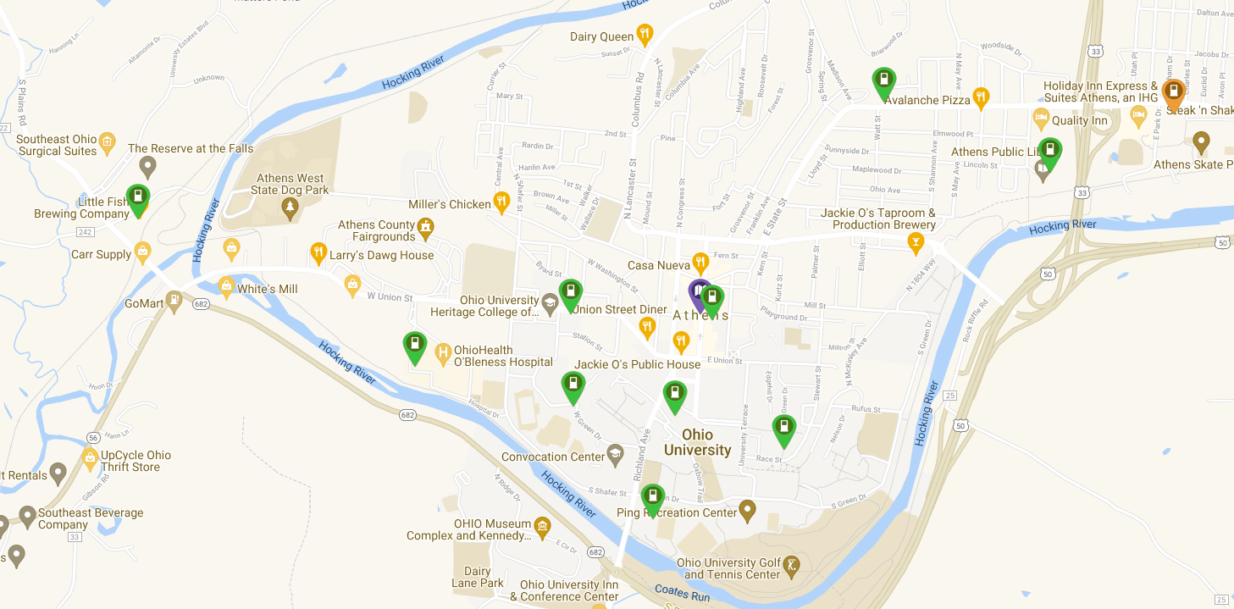
Within the City of Athens there are currently 11 EV charging locations offering 26 chargers available for public use:

- Athens City Parking Garage (2 stations, 2 plugs: J-1772)
- Athens City Pool (3 stations, 4 plugs: J-1772, CCS-SAE, CHAdeMO)
- Athens City Public Library (4 stations, 4 plugs: J-1772)
- Little Fish Brewery (1 station, 1 plug: J-1772)
- Ohio University – Baker Center Garage (1 station, 1 plug: J-1772)
- Ohio University – Human Resources Building (1 station, 1 plug: J-1772)
- Ohio University – Morton Hall Parking (2 station, 2 plugs: J-1772)
- Ohio University – Peden Stadium (2 stations, 2 plugs: J-1772)
- Ohio University – Stocker Center (2 stations, 2 plugs: J-1772)
- OhioHealth O’Bleness (3 stations, 6 plugs: J-1772)
- Village Bakery and Café (1 station, 1 plug: J-1772)

Map 4-b: Map of Current EV Chargers in Athens County
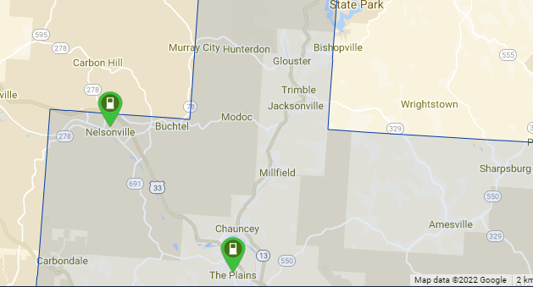

Outside of the City of Athens there is currently 2 stations offering 3 chargers located in The Plains and Nelsonville:
- Stuart’s Opera House (Nelsonville, 1 station, 1 plug: J-1772)
- Rural Action (The Plains, 2 stations, 2 plugs: J-1772)

Map 4-c: Map of Outdoor Recreation Areas in Athens County
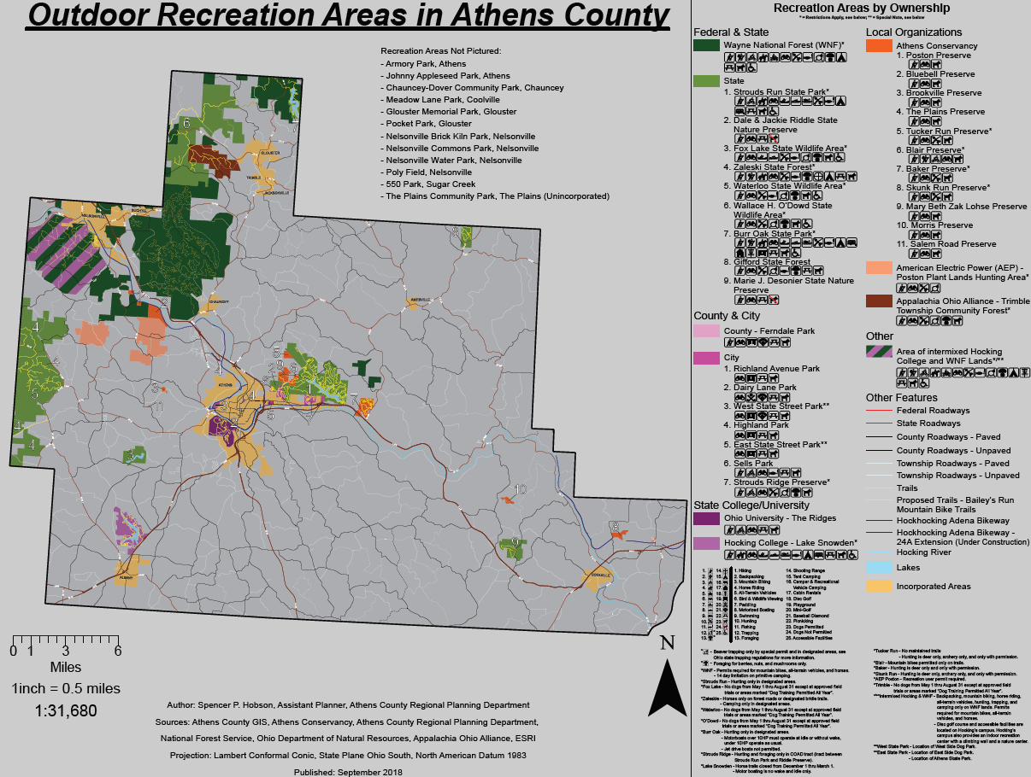
The public lands in Athens County are utilized by local community members and tourists for a variety of activities including hiking, hunting, mountain biking, trail running, birding, camping, kayaking and canoeing, among several other activities. A majority of the public lands are located in the Northwestern areas of the county.

Map 4-d: Map of Bailey’s Trail
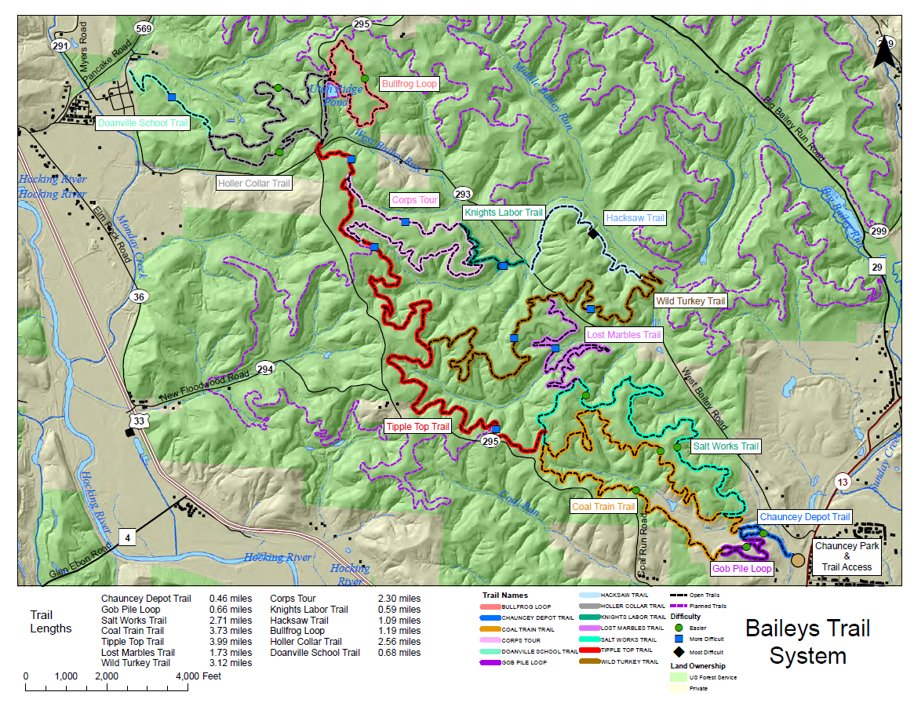
In December 2017, Wayne National Forest approved the development of Bailey’s Trail System. The development includes plans for an 88-mile single track trail system for mountain bikers, trail runners, and hikers of all skill levels. The system currently has direct community access to Chauncey and Doanville. Future expansion for connection points in Nelsonville and Buchtel are planned.

Map 4-e: Map of HockHocking Adena Bikeway
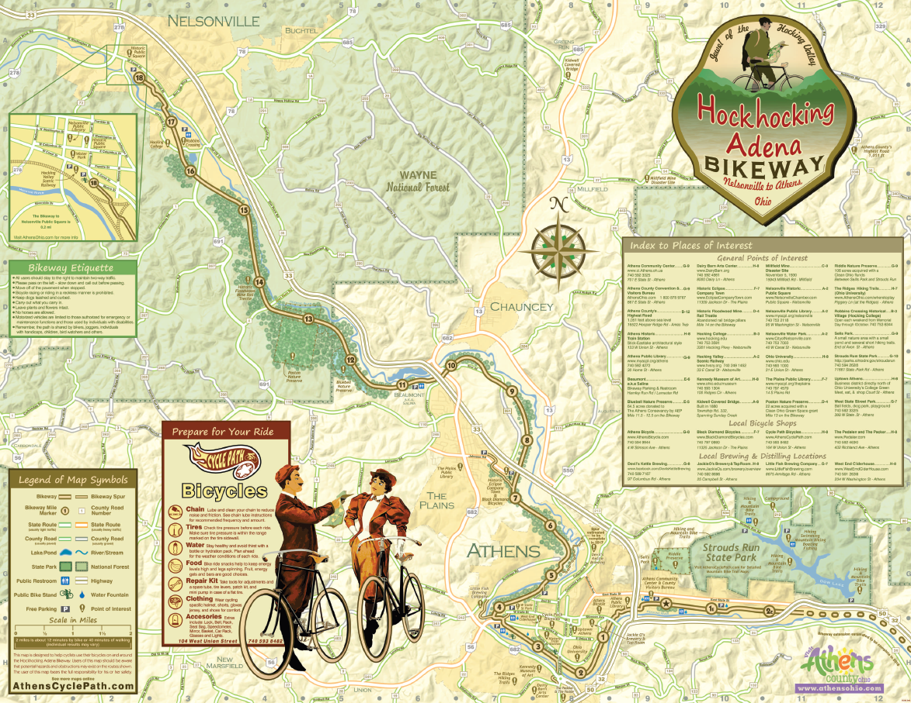
The HockHocking Adena Bikeway is 22-mile paved bikeway that spans across Athens County and connects Nelsonville to Athens. The bikeway is used by cyclists, runners, and walkers to commute to work, school, and to multiple shopping locations.
Currently there is a spur under construction that will connect the Village of Chauncey and the Bailey’s Trail head to the main HockHocking Adena Bikeway.
There are multiple entry points to the bikeway, and connections to public transportation stops and options.

The following table provides basic information about local travel training program options.
Table 5: Transportation Resources
Transportation Resource | Availability | Cost | Usage | Service Area
Athens Mobility Management | M-F  8am-4pm | Free | Community Members | The State of Ohio
Region 8 Mobility Solutions Center | M-F  8am-4pm | Free | Community Members | Region 8 / State of Ohio
HAPCAP Community Resource Navigator | M-F  8am-4pm | Free | Community Members | Athens, Hocking, and Perry County

The following table illustrates the technology used by each transportation provider for scheduling, dispatching, and/or GPS tracking vehicles.
Table 6: Technology
Agency Name | Name of Scheduling Software | Do you have an App for Transportation (Y/N)? | Name of Dispatching Software | AVL System/ GPS (Y/N)
1. Alexander School District | FMX – for field trips | No | X | N
2. Area Agency on Aging | X | X | X | X
3. Athens City-County Health Department | X | X | X | X
4. Athens City Schools | Versatrans | No | X | X
5. Athens County Board of Developmental Disabilities | X | N | X | N
6. Athens County Children Services | X | N | X | N
7. Athens County Department of Job and Family Services | X | N | X | N
8. Athens County Head Start (HAPCAP) | X | N | X | N
9. Athens County Re-Entry (ACDJFS) | X | X | X | X
10. Athens Go-To Cab | X | X | X | X
11. Athens-Hocking Mobility Management | X | X | X | X
12. Athens on Demand Transit (HAPCAP) | PC Trans | N | PC Trans | Yes
13. Athens Public Transit (HAPCAP) | X | Yes, DoubleMap | X | N
14. Athens Veterans Association | X | N | X | N
15. Athens Veterans Services | X | X | X | X
16. Athens Village | X | X | X | X
17. Buckeye Hills Regional Council – PASSPORT | X | X | X | X
18. Daybreak Transportation Services LLC | X | X | X | X
19. Echoing Connections | X | N | X | N
20. Federal Hocking School District | X | N | X | N
21. GoBus (HAPCAP) | X | Y | X | Y
22. Good Works | X | X | X | X
23. GreenCab | X | N | X | Y
24. HAVAR | X | X | X | N
25. Hocking College | X | N | X | N
26. Holzer Hospital (Athens County) | X | X | X | X
27. Hopewell Health Centers | X | X | X | X
28. Integrated Services | X | X | X | X
29. The Laurels of Athens | X | N | X | N
30. The Lindley Inn | X | N | X | N
31. Lyft | X | Y | X | Y
32. My Sister’s Place | X | X | X | X
33. Nelsonville-York School District | X | X | X | N
34. OhioHealth O’Bleness | X | X | X | X
35. Ohio University – CATS | X | X | X | X
35-a. Ohio University – CATCAB | X | X | X | X
35-b. Ohio University – CATS Late Night | X | X | X | X
35-c. Ohio University – Charter Services | X | X | X | X
36. Passion Works | X | X | X | X
37. Personnel Plus (ACBDD) | X | X | X | X
38. RHDD | X | N | X | N
39. RSVP (COAD) | X | N | X | N
40. Salvation Army | X | X | X | X
41. The Sech-Kar Company | X | N | X | N
42. The Summit Apartments | X | Yes, DoubleMap | X | Yes
43. Trimble School District | X | N | X | Yes
44. United Seniors of Athens County | X | N | X | N
45. University Commons | X | N | X | N
46. University Courtyard | X | Yes, DoubleMap | X | N

IV. Assessment of Community Support for Transit
Lack of transportation has been and continues to be a very significant problem for people living in poverty, particularly for people in rural areas such as Athens County, where there are limited public transportation options. However, Athens County has long recognized the need for transportation services in the region and has a long history of overall support for transportation initiatives.
Recognizing the need for the growth of transportation in the community, Athens County partnered with Hocking Athens Perry Community Action (HAPCAP) and the Ohio Department of Transportation (ODOT) to facilitate the Athens Mobility Management (AMM) project in January of 2010. The Mobility Management Program is a position dedicated to:
- Increasing understanding and awareness of community transportation needs
- Increasing awareness of current community transportation options and programs
- Ensuring that transportation considerations are included in local and regional planning activities
- Increasing local capacity for transportation services
- Assisting individuals with accessing all community transportation options
With the support of the County, Athens City, Athens County Department of Job and Family Services, Athens Children Services, and Athens County Board of Developmental Disabilities, HAPCAP began to manage the project and outlined in motion a plan to achieve the goals of the project in Athens County.
As HAPCAP and the AMM garnished support and formed partnerships with stakeholders, the City of Athens was granted the opportunity to create and host a non-profit inter-city bus system dedicated to connecting rural communities to cities and other parts of the state at affordable rates. The City of Athens chose HAPCAP to manage the project, and in the fall of 2010, GoBus was launched, allowing community members to ride to Columbus or Cincinnati, with stops along the way, for $10.00 one-way. As the popularity of the GoBus grew, HAPCAP and the AMM continued to conduct outreach, travel training, and transportation meetings in the community. Ohio University formed a partnership with HAPCAP and the GoBus to allow a stop at the Baker Student Center in the heart of the City of Athens for students and community members to use. In 2015 with the success of the GoBus becoming widespread several more routes were added, including service to Cleveland, Wooster, and Van Wert. Since its inception, GoBus ridership has increased exponentially and continues to rise with a current state-wide needs study being conducted in partnership with the ODOT.
With the success of the GoBus program continuing to rise, the City of Athens began to look at their own Athens Public Transit (APT) system, which was operating inadequately with little support or outreach. The City of Athens decided that it was time to overhaul their current fixed-route system and released a Request for a Proposal for a new management organization to run APT. In 2012 the City of Athens chose HAPCAP, and later that year, the wholly renovated APT system was revealed. Since its start in 2012, APT has expanded to serve The Plains and Chauncey, lengthen hours, provide services to apartment complexes in the area, and partner with Ohio University to create the Bobcat Pass, allowing all students, facility, and staff to ride for free.
That same year the AMM, HAPCAP, and several partnering organizations created a pilot project consisting of a fleet of accessible vans that can travel door-to-door and county-wide at an affordable price. HAPCAP, with its partners, started a pilot project to serve seniors, individuals with disabilities, and low-income individuals. In the fall of 2012, Athens On-Demand Transit (AODT) began to serve the entirety of the county, offering $2.00 one-way rides anywhere in the county. The need for such a service was quickly proven as AODT has continuously expanded its capacity to accommodate the number of community members in need of such a service. In addition, AODT partnered with Athens County Job and Family Services to provide rides to wheelchair-bound community members and often works with local hospitals and medical facilities.
In summer 2019, HAPCAP, with the support of several community partners, was able to start a pilot project providing fixed-route service to the City of Nelsonville and the Village of Albany to and from the City of Athens. Dubbed "Line 7", the need for this type of service as outlined in the 2018 Athens County Coordinated Plan. Line 7 became part of APT's regular service in 2020.
AODT and APT merged into one system to serve Athens County better in January 2020. With this change, AODT's funding transitioned from 5310 to 5311. In addition, AODT, which originally primarily served individuals with disabilities and the elderly, opened to the general public throughout the county. This merger and expansion evolved from the 2018 Coordinated plan to provide more county-wide service.
As transportation options in Athens County continued to grow, the opportunities for coordinated transportation efforts followed suit. The Athens Mobility Management Program serves as the coordinating force for organizations and individuals. Financial and managerial support for the program has been. Currently, it is provided by the Ohio Department of Transportation, Athens County, Athens City, Athens County Board of Developmental Disabilities, Athens County Children Services, Hocking Athens Perry Community Action, and Athens County Job and Family Services. AMM continues to support transportation and active transportation efforts, conduct outreach and training to individuals and organizations, and advocate for transportation at local meetings, including:
- ATCO Transition Meeting
- Athens Area Stand Down Planning Committee
- Athens City Disabilities Committee
- Athens City Disabilities Committee
- Athens County Complete Streets Formation Committee
- Athens County Coordinated Plan Planning Committee (hosted by the Mobility Manager)
- Athens County Council on Aging
- Athens County Transportation Meetings (hosted by the Mobility Manager)
- Athens Re-Entry Task Force
- Athens Regional Planning Committee
- Athens-Belpre Rail Trail
- Buckeye Hills Transportation Development Committee
- City of Athens Transportation Task Force
- Ohio Action Institute (Member of Athens Area team)
- Ohio Department of Transportation Mobility Managers meeting
- Ohio Public Transportation Association Conferences
- Ohio University Transportation
- Senior Safety Day Planning Committee

Safety
All transportation providers in Athens County are dedicated to ensuring safe transportation for all riders, drivers, and pedestrians. Although different providers require different safety courses for their drivers there are requirements for each provider to ensure safe practices.
Several transportation providers listed in this plan are part of the county-wide emergency response plan.

Vehicles
Survey/Interview participants listed a combined total of 248 vehicles. Approximately 34% of the vehicles are wheelchair accessible. A vehicle utilization table is provided at the end of this chapter (Table 6). Several transportation providers did not provide information for the Vehicle Utilization Form but did provide information regarding the number of vehicles and wheel chair accessible vehicles in their fleets. Those numbers are reflected in the total amount of vehicles listed above and in the remainder of this document.
Provider | Vehicles | Wheel Chair
Alexander School District | 37 | 3
Athens City School District | 36 | 3
Athens County Board of Developmental Disabilities | 28 | 23
Athens County Head Start | 6 | 6
Athens Veterans Association | 7 | 0
Echoing Connections | 4 | 4
Federal-Hocking School District | 27 | 2
HAVAR | 2 | 1
Hocking College | 85 | 1
Integrated Services | 1 | 0
Nelsonville-York School District | 25 | 2
Passion Works / Creative Foundations | 2 | 2
The Sech-Kar Company | 4 | 3
Trimble School District | 17 | 1
University Commons Apartments | 2 | 0
Total | 142 | 38

All of the transportation providers provide at least 1 wheelchair accessible vehicle, while some organizations have an entire fleet of wheelchair accessible vehicles. Currently, wheelchair accessible vehicles available to the public are only available during certain hours and days. The need for these vehicles remains high as several providers are running at full capacity and denying ride requests. Numerous organizations purchase services from providers to provide wheelchair accessible transportation to their clients as a contract service.
As vehicles age, they require additional maintenance, may break down more often, and become costlier to operate. Vehicle replacement, based on age and condition, is vital to the overall cost effectiveness of the transportation services provided.
Vehicle Utilization Table

Veh # | Make | Model | Year | Vin # | Capacity | WC Capacity | Days of the Week Vehicle is in Service |  | Service Hours | Vehicle Condition | Program to which Vehicle is Assigned (if applicable) | Service Area
Athens County Job and Family Services
850YZK | GMC | Savana | 2017 | 1GJZ7NFFXH1206596 | 15 | No | Monday-Friday |  | 8 | Great | Transportation | Athens County
515YZG | Honda | CRV | 2017 | 5J6RW2H88HL017421 | 5 | No | Monday-Friday |  | 8 | Great | Transportation | Athens County
620YWM | Dodge | Caravan | 2016 | 2C4RDGCG0GR331560 | 7 | No | Monday-Friday |  | 8 | Great | Transportation | Athens County
762YPP | Chevrolet | Impala | 2014 | 2G1WA5E30E1138228 | 5 | No | Monday-Friday |  | 8 | Great | Transportation | Athens County
529YDZ | Dodge | Caravan | 2010 | 2D4RN4DE4AR282109 | 7 | No | Monday-Friday |  | 8 | Great | Transportation | Athens County
Athens County Children Services
OF6939 | Chevy | Impala | 2008 | 261WB58K281213659 | 5 | No |  | 5 | 8 | Fair | Transportation | Athens County
GJE1694 | Dodge | Caravan | 2009 | 2D8HN4E69R94036 | 7 | No |  | 5 | 8 | Good | Transportation | Athens County
737YMZ | Ford | E350 Van | 2010 | 1FNBE3812ADA45603 | 12 | No |  | 5 | 8 | Good | Transportation | Athens County
769YFZ | Dodge | Ram 2500 | 2011 | 3D7LT2ET1GB551514 | 3 | No |  | 5 | 8 | Good | Maintenance | Athens County
782YPP | Chevy | Traverse | 2013 | 1GNKVFED8EJ181690 | 8 | No |  | 5 | 8 | Good | Transportation | Athens County
786YPP | Chevy | Traverse | 2013 | 1GNKVFEDXEJ216357 | 8 | No |  | 5 | 8 | Good | Transportation | Athens County
398YMF | Chevy | Cargo Van | 2013 | 1GCZGTCGXD1107666 | 2 | No |  | 5 | 8 | Good | All | Athens County
Athens Public Transit
221 | Gillig | LF 30' | 2002 | M15GGE181221090518 | 53 (29/24) | 2 | Mon-Sat |  | X | Fair | Athens 5311 | 38 sq. miles
223 | Gillig | LF 30' | 2002 | M15GGE181021090520 | 53 (29/24) | 2 | Mon-Sat |  | X | Fair | Athens 5311 | 38 sq. miles
9800 | New Flyer | D35 LF | 1998 | 5FYD2SL07WU018189 | 65 (35/30) | 2 | Mon-Sat |  | X | Fair | Athens 5311 | 38 sq. miles
1100 | Ford | Goshen Coach GC II | 2011 | 1FDFE4FS7BDA09927 | 24 (18/6) | 2 | Mon-Sat |  | X | Fair | Athens 5311 | 38 sq. miles
1300 | Ford | Goshen Coach GC II | 2013 | 1FDFE4FS2DDA20661 | 25 (18/7) | 2 | Mon-Sat |  | X | Good | Athens 5311 | 38 sq. miles
1400 | Ford | Goshen Coach GC II | 2014 | 1FDFE4FS4FDA10653 | 25 (18/7) | 2 | Mon-Sat |  | X | Good | Athens 5311 | 38 sq. miles
1401 | Ford | Starcraft Allstar XL | 2014 | 1FDGF5GY5FEA42547 | 40 (30/10) | 2 | Mon-Sat |  | X | Good | Athens 5311 | 38 sq. miles
1600 | Ford | Champion LF | 2016 | 1FDFE4FS5GDC25850 | 30 (22/8) | 2 | Mon-Sat |  | X | Excellent | Athens 5311 | 38 sq. miles
1601 | Ford | Champion LF | 2016 | 1FDFE4FS7GDC25851 | 30 (22/8) | 2 | Mon-Sat |  | X | Excellent | Athens 5311 | 38 sq. miles
1602 | Ford | Champion LF | 2016 | 1FDFE4FS8GDC54937 | 30 (22/8) | 2 | Mon-Sat |  | X | Excellent | Athens 5311 | 38 sq. miles
1700 | Ford | Champion LF | 2017 | 1FTYR2XM6HKA84547 | 9 (9/0) | 2 | Mon-Sat |  | X | New | Athens 5311 | 38 sq. miles
Athens On-Demand Transit
101 | Honda | Odyssey | 2002 | 2HKRL18662H590644 | 6 | 0 | Monday-Friday |  | 26 | Fair | AODT | Athens County
103 | Dodge | Grand Caravan | 2012 | 2C4RDGBG5CR398508 | 5 | 1 | Monday-Friday |  | 32 | Fair | AODT | Athens County
104 | Dodge | Grand Caravan | 2013 | 2C4RDGBG6DR617493 | 5 | 1 | Monday-Friday |  | 32 | Fair | AODT | Athens County
105 | Dodge | Grand Caravan | 2013 | 2C4RDGBG8DR617494 | 5 | 1 | Monday-Friday |  | 32 | Good | AODT | Athens County
106 | Dodge | Grand Caravan | 2014 | 2C7WDGBG7ER380116 | 5 | 1 | Monday-Friday |  | 32 | Good | AODT | Athens County
109 | Dodge | Grand Caravan | 2017 | 2C7WDGB0HR618327 | 5 | 1 | Monday-Friday |  | 32 | Excellent | AODT | Athens County
Residential Home for the Developmentally Disabled (RHDD)
109 | Toyota | Corolla | 2011 | 2T1BU4EE6BC590397 | X | N | X |  | X | X | X | Athens County
4 | Ford | E-450 | 2008 | 1FD4E45S78DA05491 | X | Y | X |  | X | X | X | Athens County
115 | Dodge | Grand Caravan | 2014 | 2C4RDGCG8ER155342 | X | Y | X |  | X | X | X | Athens County
119 | Dodge | Caravan 9007 | 2015 | 2C4RDGBG2FR749007 | X | N | X |  | X | X | X | Athens County
15 | Ford | E350 Bus 8802 | 2016 | 1FDEE3FS6GDC18802 | X | Y | X |  | X | X | X | Athens County
110 | Dodge | Grand Caravan | 2010 | 2D4RN4DE9AR497632 | X | Y | X |  | X | X | X | Athens County
114 | Toyota | Rav-4 | 2012 | JTMBF4DVXC5055308 | X | N | X |  | X | X | X | Athens County
124 | Dodge | Grand Caravan | 2015 | 2C4RDGBG7FR623256 | X | Y | X |  | X | X | X | Athens County
17 | Ford | Goshen Coach 17 | 2017 | 1FDEE3FS5HDC47886 | X | Y | X |  | X | X | X | Athens County
Ohio University
29106 | MCI | J4500 | 2016 | 2MG3JM8AXGW067355 | 56 | Y | Varies |  | Varies | Good | Ohio Transit - Charter Buses | Varies
29109 | VanHool | C2045E | 2007 | YE2CC17B472047263 | 56 | Y | Varies |  | Varies | Good | Ohio Transit - Charter Buses | Varies
29150 | Ford | F650 Starcraft XLT | 2017 | 1FDWFDEXHDB05419 | 30 | Y | Varies |  | Varies | Excellent | Ohio Transit - Charter Buses | Varies
29346 | VanHool | C2045 | 2003 | YE2CC12B132045892 | 56 | Y | Varies |  | Varies | Good | Ohio Transit - Charter Buses | Varies
29465 | Ford | Cutaway E350 Super Duty | 2012 | 1FDEE3FL2CDA13464 | 15 | Y | Varies |  | Varies | Good | Ohio Transit - Fixed Routes | Varies - Primarily Campus Based
S29893 | Ford | E350 Starcraft | 2017 | 1FDEE3FS1HDC34066 | 15 | Y | Varies |  | Varies | Excellent | Ohio Transit - Fixed Routes | Varies - Primarily Campus Based
 |  | Allstar
S29894 | Ford | E350 Starcraft | 2017 | 1FDEE3FS7HDC33634 | 15 | Y | Varies |  | Varies | Excellent | Ohio Transit - Fixed Routes | Varies- Primarily Campus Based
 |  | Allstar
29387 | Ford | E350 Starcraft Cutaway | 2014 | 1FDEE3FL0EDA68918 | 15 | Y | Varies |  | Varies | Good | Ohio Transit - Fixed Routes | Varies - Primarily Campus Based
29537 | Ford | Starcraft E350 | 2016 | 1FDEE3FL2GDC16294 | 15 | Y | Varies |  | Varies | Good | Ohio Transit - Fixed Routes | Varies - Primarily Campus Based
29538 | Ford | Starcraft E350 | 2016 | 1FDEE3FL5GDC16287 | 15 | Y | Varies |  | Varies | Good | Ohio Transit - Fixed Routes | Varies - Primarily Campus Based
29544 | MV-1 | DX ADA Van | 2016 | 57WMD2C68GM100007 | 4 | Y | 5 |  | M-F | Good | Ohio Transit - ADA | Campus 2 Miles
29518 | MV-1 | DX ADA Van | 2014 | 57WMD1A66EM101389 | 4 | Y | 5 |  | M-F | Good | Ohio Transit - ADA | Campus 2 Miles
29416 | Ford | F350 XL Super Duty | 2008 | 1FBNE31L78DA99751 | 12 | No | Varies |  | Varies | Good | Ohio Rental Fleet | Varies
29417 | Ford | E350 XL Super Duty | 2008 | 1FBNE31L98DA99752 | 12 | No | Varies |  | Varies | Good | Ohio Rental Fleet | Varies
29420 | Chevrolet | Impala LS | 2008 | 2G1WB58KX81313931 | 5 | No | Varies |  | Varies | Good | Ohio Rental Fleet | Varies
29444 | Ford | Econoline E350 Super Duty | 2010 | 1FBNE3BL7ADA54121 | 12 | No | Varies |  | Varies | Good | Ohio Rental Fleet | Varies
29460 | Chevrolet | Cruze LT | 2012 | 1G1PC5SH3C7225927 | 5 | No | Varies |  | Varies | Good | Ohio Rental Fleet | Varies
29461 | Chevrolet | Cruze Lt | 2012 | 1G1PC5SH8C7225907 | 5 | No | Varies |  | Varies | Good | Ohio Rental Fleet | Varies
29462 | Chevrolet | Cruze LT | 2012 | 1G1PC5SH1C7226011 | 5 | No | Varies |  | Varies | Good | Ohio Rental Fleet | Varies
29463 | Chevrolet | Cruze LT | 2012 | 1G1PC5SH7C7226773 | 5 | No | Varies |  | Varies | Good | Ohio Rental Fleet | Varies
29468 | Ford | Econoline E350 | 2012 | 1FBNE3BLXCDB17697 | 12 | No | Varies |  | Varies | Good | Ohio Rental Fleet | Varies
29469 | Ford | Econoline E350 Super Duty | 2012 | 1FBNE3BL1CDB17698 | 12 | No | Varies |  | Varies | Good | Ohio Rental Fleet | Varies
29470 | Ford | Econoline E350 Super Duty | 2012 | 1FBNE3BL3CDB17699 | 12 | No | Varies |  | Varies | Good | Ohio Rental Fleet | Varies
29471 | Ford | Econoline E350 Super Duty | 2012 | 1FBNE3BL6CDB17700 | 12 | No | Varies |  | Varies | Good | Ohio Rental Fleet | Varies
29472 | Ford | Econoline E350 Super Duty | 2012 | 1FBNE3BL8CDB17701 | 12 | No | Varies |  | Varies | Good | Ohio Rental Fleet | Varies
29473 | Ford | Econoline E350 Super Duty | 2012 | 1FBNE3BLXCDB17702 | 12 | No | Varies |  | Varies | Good | Ohio Rental Fleet | Varies
29476 | Ford | Econoline E350 Super Duty | 2012 | 1FBNE3BL5CDB17705 | 12 | No | Varies |  | Varies | Good | Ohio Rental Fleet | Varies
29477 | Ford | Econoline E350 Super Duty | 2012 | 1FBNE3BL7CDB17706 | 12 | No | Varies |  | Varies | Good | Ohio Rental Fleet | Varies
29479 | Ford | Econoline E350 Super Duty | 2012 | 1FBNE3BL0CDB17708 | 12 | No | Varies |  | Varies | Good | Ohio Rental Fleet | Varies
29484 | Chevrolet | G2500 | 2013 | 1GAWGPFA2D1145435 | 12 | No | Varies |  | Varies | Good | Ohio Rental Fleet | Varies
29485 | Chevrolet | G2500 | 2013 | 1GAWGPFA7D1145043 | 12 | No | Varies |  | Varies | Good | Ohio Rental Fleet | Varies
29488 | Ford | E-150 XL Wagon | 2013 | 1FMNE1BW3DDB14874 | 8 | No | Varies |  | Varies | Good | Ohio Rental Fleet | Varies
29491 | Ford | E-150 XL Wagon | 2013 | 1FMNE1BW1DDB14873 | 8 | No | Varies |  | Varies | Good | Ohio Rental Fleet | Varies
29492 | Ford | E-150 XL Wagon | 2013 | 1FMNE1BWXDDB14872 | 8 | No | Varies |  | Varies | Good | Ohio Rental Fleet | Varies
29499 | Ford | Focus SE | 2014 | 1FADP3F28EL133401 | 5 | No | Varies |  | Varies | Good | Ohio Rental Fleet | Varies
29500 | Ford | Focus SE | 2014 | 1FADP3F2XEL133402 | 5 | No | Varies |  | Varies | Good | Ohio Rental Fleet | Varies
29502 | Honda | Pilot LX | 2014 | 5FNYF4H28EB011559 | 8 | No | Varies |  | Varies | Good | Ohio Rental Fleet | Varies
29503 | Honda | Insight LX | 2013 | JHMZE2H53DS005156 | 5 | No | Varies |  | Varies | Good | Ohio Rental Fleet | Varies
29504 | Honda | Insight LX | 2013 | JHMZE2H57DS004351 | 5 | No | Varies |  | Varies | Good | Ohio Rental Fleet | Varies
29505 | Honda | Odyssey LX | 2014 | 5FNRL5H27EB048377 | 7 | No | Varies |  | Varies | Good | Ohio Rental Fleet | Varies
29506 | Honda | Odyssey LX | 2014 | 5FNRL5H29EB002114 | 7 | No | Varies |  | Varies | Good | Ohio Rental Fleet | Varies
29507 | Honda | Pilot LX | 2014 | 5FNYF4H29EB017354 | 8 | No | Varies |  | Varies | Good | Ohio Rental Fleet | Varies
29508 | Honda | Pilot LX | 2014 | 5FNYF4H2XEB011322 | 8 | No | Varies |  | Varies | Good | Ohio Rental Fleet | Varies
29509 | Honda | Pilot LX | 2014 | 5FNYF4H20EB017338 | 8 | No | Varies |  | Varies | Good | Ohio Rental Fleet | Varies
29525 | Chevrolet | Volt Hybrid | 2014 | 1G1RB6E49EU169720 | 5 | No | Varies |  | Varies | Good | Ohio Rental Fleet | Varies
29540 | Chevrolet | Malibu LS | 2016 | 1G1ZB5ST6GF346401 | 5 | No | Varies |  | Varies | Good | Ohio Rental Fleet | Varies
29542 | Chevrolet | Malibu | 2016 | 1G1ZB5STXGF261142 | 5 | No | Varies |  | Varies | Good | Ohio Rental Fleet | Varies
29543 | Chevrolet | Malibu | 2016 | 1G1ZB5ST8GF268736 | 5 | No | Varies |  | Varies | Good | Ohio Rental Fleet | Varies
29545 | Chevrolet | Malibu | 2017 | 1G1ZB5ST0HF159981 | 5 | No | Varies |  | Varies | Excellent | Ohio Rental Fleet | Varies
29546 | Chevrolet | Malibu | 2017 | 1G1ZB5ST9HF235942 | 5 | No | Varies |  | Varies | Excellent | Ohio Rental Fleet | Varies
29547 | Chevrolet | Malibu | 2017 | 1G1ZB5ST7HF134558 | 5 | No | Varies |  | Varies | Excellent | Ohio Rental Fleet | Varies
S29753 | Chevrolet | Chevy Express G1500 | 2001 | 1GCEG15W011244313 | 2 | No | Varies |  | Varies | Fair | Ohio Rental Fleet | Varies
S29799 | GMC | Savana G3500 | 2006 | 1GCHG35V161129789 | 2 | No | Varies |  | Varies | Fair | Ohio Rental Fleet | Varies
Veh # | Make | Model | Year | Vin # | Capacity | WC Capacity | Days of the Week Vehicle is in Service | Service Hours | Vehicle Condition | Program to which Vehicle is Assigned (if applicable) | Service Area
United Seniors

1 | Chevy | Uplander | 2005 | 1GNDV23L45D169384 | 7 | NO | Mon-Fri | 3-Aug | Fair | Aging (60+) Programs | ATHENS COUNTY
2 | Chevy | Express Van | 2008 | 1GAGG25K681119881 | 12 | NO | Mon-Fri | 3-Aug | Good | Aging (60+) Programs | ATHENS COUNTY
3 | Dodge | Grand Caravan | 2014 | 2C4RDGCG8ER187031 | 5 | 1 | Mon-Fri | 3-Aug | Excellent | Aging (60+) Programs | ATHENS COUNTY

Summary of Existing Resources
An overall summary of existing resources and an inventory of current services allows better insight into opportunities to coordinate services and the transportation gaps currently in the county.
Athens County has several public and private transportation providers. Multiple providers provide services to clients who qualify under certain criteria or are associated with the organization and its services. Other providers are open to the public and available with no requirements.
The summary of existing resources illustrates gaps in services in the county including:
- Little availability of public and accessible services on the weekends and during the early morning and evening hours during the week.
- Limited county-wide affordable services.
- A lack of services that operate outside of Athens County.
- Limited education and awareness regarding services provided throughout Athens County.
- A small number of non-emergency medical transportation providers open to the public.
- A need for coordination of efforts, especially with wheelchair accessible vehicles.
- Limited strategies enabling transportation to evolve with developing technologies.

V. Assessment of Transportation Needs and Gaps
Express survey in an effort to better understand Athens County’s needs, the planning committee examined research and data, as well as solicited input from the community in an effort to gather information about needs and gaps in transportation services.
The demographic and socio-economic conditions of the study area are discussed in the Demographics Chapter of this plan. The following overview is an evaluation of the gaps in service based upon geographic data as well as from the perspective of the targeted populations, transportation providers, and the general public.
Athens County coordinated a variety of stakeholders in the area in an attempt to solicit input and request participation from any organization that could potentially be impacted by the coordinated transportation planning process. More information on how the lead agency engaged stakeholder and the general public is available upon request.
The following methods were used to assess transportation needs and gaps
- Assessment of population data and demographics
- Evaluation of existing services including service reduction and service growth
- In 2021, a total of 5 virtual meetings were held with city and county stakeholders
- Analyzed trip requests made to mobility management program
- Release of seven (7) transportation surveys to the county focused on:
  - General public
  - Seniors
  - Individuals with Disabilities
  - Transportation Providers
  - Social Service Providers / Non-Profits
  - Businesses
  - Express
*Due to COVID-19 Pandemic and the hire date of the Mobility Coordinator, surveys did not get distributed as widely this year for data collection. The Mobility Coordinator reached out to stakeholders individually, via email and phone to gather information to provide current updates.

Local Demographic and Socio-Economic Data
Data for each target population group were aggregated by Census Block Group for transportation analysis. The demographic and socio-economic data is valuable because a comparison of where the highest and lowest densities individuals who are most likely to need transportation live. This information can then be compared to the locations of (1) major trip generators, and (2) available transportation services.
The following exhibit illustrates the areas where the number of older adults (age 65 and older) is at or above the national average.

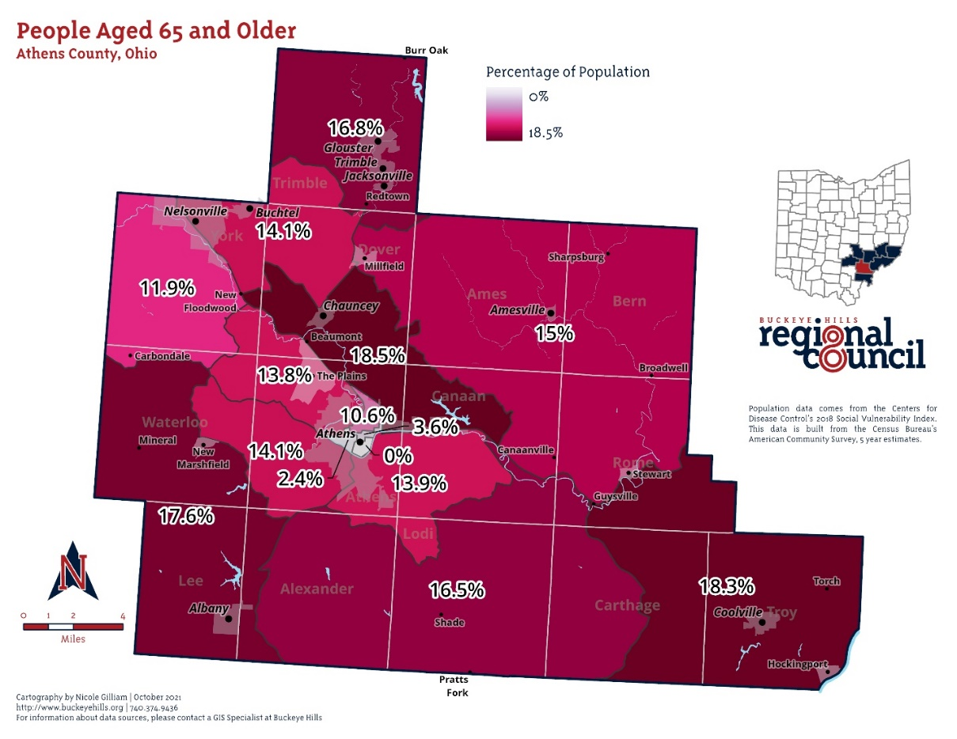
Exhibit 1: Map of Population Density of Individuals Age 65 and Older

The exhibit below indicates the areas where the number of zero vehicle households is above the national average. The absence of a vehicle in the household is often an indication of the need for transportation services.

Exhibit 2: Map of Density of Zero Vehicle Households

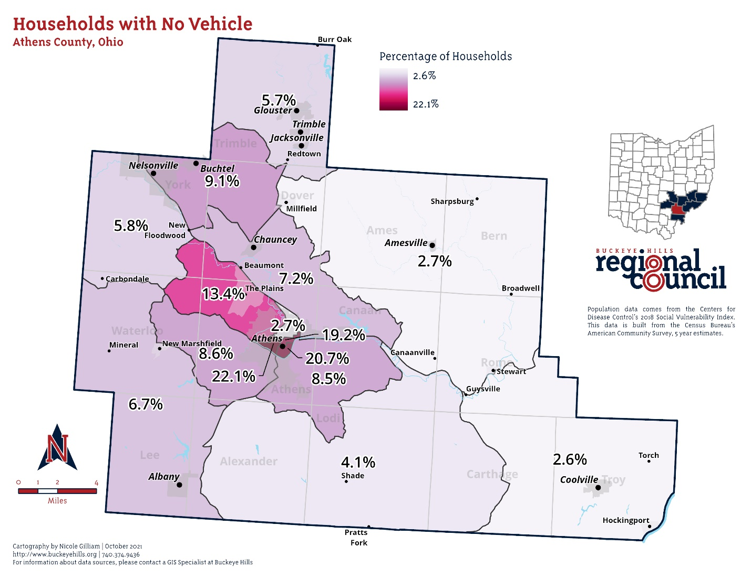

The next exhibit illustrates the location of the top destinations for the existing transportation providers as well as major trip generators for anyone in the area, including those who drive a personal vehicle.
Exhibit 3: Map of Major Trip Generators

Major healthcare facilities including hospitals, mental health facilities, and urgent care branches include:

- OhioHealth
- Hopewell Health Centers
- OhioHealth & Integrated Services (Mary Hill Center)
- Integrated Services for Behavioral Health
- Athens City-County Health Department
- Holzer Health Care

Major social services agencies in the county include:

- Athens City-County Health Department
- Athens County Board of Developmental Disabilities
- Athens County Children Services
- Athens County Court House
- Athens County Department of Job and Family Services
- Hocking Athens Perry Community Action
- Integrated Services

Analysis of Demographic Data

The density of individuals age 65 and older is concentrated in the rural areas of the County, markedly along the 33 corridor between Athens City and Nelsonville and in the Southeastern area of the County, surrounding Coolville. These areas have the least amount of affordable transportation options available to them. Most seniors in Athens County reside outside of the city limits in areas further away from medical care facilities and senior services.
A high percentage of no vehicle households are within the Athens City limits as well as the 33 corridor between Athens City and Nelsonville, as seen in Exhibit 2, revealing a population in need of transportation services or programs.
Major trip generators are located mostly in Athens City and Nelsonville. The rural areas of the county need to travel to these cities in order to gain access to job opportunities, medical facilities, food access, and educational institutions.
Based on the demographic data above, it is crucial that affordable transportation options are available for community members residing in the rural areas of the county, especially seniors and no vehicle households, in order to connect them to a variety of services available elsewhere in the county.

General Public and Stakeholder Meetings/Focus Groups

Normally Public meetings are held to gather data and information but due to the COVID-19 Pandemic and hire date of the Mobility Manager, in person meetings to update the Coordinated Plan were unable to be held. The current Mobility Manager, who was hired mid-December did reach out to stakeholders and health and human service agencies via email and phone to discuss and receive current information needed to update the Coordinated Plan and any goals or strategies that needed added or had been achieved.
A planning meeting was held virtually where the Hocking Athens Perry Community Action and the Athens-Hocking County Mobility Management Program presented highlights of historical coordinated transportation in the Athens County, and discussed the activities since the last Coordinated Public Transit Human Services Transportation Plan that have helped to address some of the unmet transportation needs and gaps in services for the area.
The planning committee were asked to review the gaps in transportation services and needs from the previous plan/or update and identify any gaps that were no longer valid and any new needs/gaps, which the facilitator deleted/added to/from a list. The focus of the discussion was transportation for older adults, individuals with disabilities, and people with low incomes. However, several topics discussed also impact mobility options for the general public.
After the changes to the needs/gaps list were completed and new needs/gaps were added, each participant was asked to rank the needs/gaps as a high, medium, or low priority or that the remaining gap/need should be deleted.
Participants discussed more than 10 mobility issues to achieve, preserve, avoid, or eliminate through coordination during the meeting[s]. Coordinated transportation stakeholders will consider these unmet needs when developing transportation goals and strategies, and grant applications. The exhibit at the end of this section provides a summary of the unmet mobility needs discussed during the meeting as well as the needs identified by the survey results.

Surveys
The following survey summary includes the information gained from the following surveys that were performed. 157 surveys were completed. Total surveys completed are as follows:
- General Public: 94
- Individuals age 60+: 36
- Individuals with Disabilities: 8
- Non-Profit / Social Services: 4
- Transportation Providers: 10
- Business: 3
- Express: 2
Lower than anticipated responses, as a result of COVID-19 protocols, has been attributed to the inability to host roundtable events throughout the county, lack of reliable internet for many areas of the county, and the closure or reduction of hours for many providers (specifically senior centers and services provided to individuals with disabilities.)
All questions allowed respondents to mark multiple answers or no answer at all in order to capture a more complete response. Because of this some percentages and numbers may not match the total number of respondents. Copies of the surveys can be requested by reaching out to the Athens-Hocking Mobility Coordinator, Bryan Hinkle, at bryan.hinkle@hapcap.org.

Athens County Transportation Survey for the General Public

Table 1: Survey Respondents’ Ages
Age |  | Percent
0-20 | 6 | 6.2%
21-40 | 44 | 46.8%
41-64 | 38 | 40.4%
65+ | 6 | 6.4%

Table 1 illustrates that the survey captured responses from all age groups.
Table 2: Self-Identified Respondents
Self-Identified |  |  | Percent
Disabled | 8 |  | 8.7%
Low-Income | 27 |  | 29.3%
Elderly (60+) | 11 |  | 12%
None of the Above | 55 |  | 59.8%

Table 2 illustrates that the general public, low-income, elderly, and disabled individuals participated.
Table 3: Number of Individuals in the Household
Number of People
in Household |  | Percent
1 | 13 | 14%
2 | 32 | 34.4%
3 | 16 | 17.2 %
4 | 18 | 19.4%
5 | 12 | 12.9%
6 | 2 | 2%
Table 3 shows that most respondents’ live households with two to four members.

Table 4: Residence Locations of Respondents
Residence |  | Percent
Athens City | 40 | 44.9%
Nelsonville | 4 | 4.5%
The Plains | 5 | 5.6%
Glouster | 15 | 16.9%
Albany | 2 | 2.3%
Millfield | 5 | 5.6%
Amesville | 4 | 4.5 %
Trimble | 4 | 4.5%
Buchtel | 1 | 1.1%
Jacksonville | 2 | 2.3%
*Other areas identified are located outside of city or village limits or outside the County.
Table 4 demonstrates the survey captured responses from multiple areas of the county.
Work Location |  | Percent
0-5 miles | 34 | 36.6%
6-10 miles | 12 | 12.9%
11-20 miles | 14 | 15.1%
21-30 miles | 10 | 10.8%
30+ miles | 3 | 3.2%
I am not currently employed | 14 | 15.1%
Work from home | 6 | 6.5%
Table 5: Location of Survey Respondents’ Place of Employment

Table 5 identifies a large number of respondents’ who are currently employed live with 20 miles of their work location.

Table 6: Location of Survey Respondents’ Destinations
Destinations |  | Percent
To shopping / grocery store | 85 | 92.4%
To medical facilities | 73 | 79.4%
To work | 70 | 76.1%
To visit family and friends | 60 | 65.2%
Destination outside of Athens County | 50 | 54.4%
To school/class | 20 | 21.7%
To social service agency | 16 | 17.4%
To Court / legal services | 9 | 9.8%
To food pantries | 8 | 8.7%
*Other responses included church, recreational activities such as hiking trails or parks, and children’s sporting events.
Table 6 identifies popular destinations as grocery shopping, doctors’ appointments, and destinations located in Athens City. People appear to be traveling more so that they can visit their friends and family.

Table 7: Mode of Transportation
Mode of Transportation |  | Percent
I drive my own car | 75 | 80.7%
I walk | 44 | 47.3%
I ride with a family member | 40 | 43.0%
I ride my bicycle | 31 | 33.3%
I ride with a friend | 31 | 33.3%
I use public transit | 25 | 26.9%
I use a ride hail service (Lyft or Uber) | 9 | 9.7%
I use an electric scooter | 4 | 4.3%
I call a social service provider | 2 | 2.2%
I use a taxi | 2 | 2.2%
*Other response included skateboard as mode of transportation
Table 7 shows a wide-range of transportation options used by individuals including driving their own car, walking, or riding with a family member or friend.

Table 8: Statements that Have Been True for Respondents in the Year
Statement |  | Percent
My vehicle is broken down | 15 | 35.7%
I can’t afford to use a taxi or ride share | 15 | 35.7%
I do not have a vehicle | 14 | 33.3%
I can’t afford gasoline | 13 | 30.9%
My vehicle is not reliable | 9 | 21.4%
I do not have a driver’s license | 8 | 19.1%
I can't afford car insurance | 6 | 14.3%
I do not have car insurance | 4 | 9.5%
My driver's license is suspended | 3 | 7.1%
I can’t afford to renew my license/registration | 3 | 7.1%

Table 8 identifies several transportation barriers related to unreliable personal vehicles and the financial hardship of owning and operating a personal vehicle.

Table 9: Key Insights
The comments left by participants to the question: ‘What Improvements should be made to the current transportation services in Athens County?” The most frequent responses were:
- Expansion of service area to a County-wide service, especially to Glouster/Trimble Township.
- Extension of public transportation hours for commuters (earlier / later and weekend services)
- More capacity of current services
- Outreach and education about current transportation services available

Notable Comments
"Routes to surrounding villages."
“Longer hours More frequent stops on each route (more buses driving) cheaper fares, $1 for every leg of a trip??”
"More hours more stops more buses."
“Saturday operation."
"Bike path extended to Glouster."
"Please make it possible to get to Glouster. Those of us who need HAPCAP are at our wits end."
“Need better explanation/display of routes and times.”
"Expanded services."
"More locations with stops."
"More weekend options for students without cars…"
"More frequent stops…earlier/later options…better marked bus stops."
"Evening hours."
"I love line 7, but it's been more inconvenient to use since it now only runs every other hour. I also wish there was a bus to Glouster.."
"More rural routes."
"Farther range."
"Advertise more."
"Access to Glouster, Millfield area (Trimble etc)"
"New routes, cheaper fare for people who aren’t getting public assistance."
"Routes to Glouster."
"Adding an hour or two to the early morning and evening bus routes, specifically the Plains."
"Longer hours, more days, more frequent, new routes, monthly passes."
"New routes outside the city of Athens.”
"Better at letting riders know when they are not running."
"Operating on Sunday."
“Late night hours"
"Sunday services."
“Better bus stops with shelters and benches at all locations…better signage.”

Table 10: Key Insights 2
The comments left by participants to the question: ‘What improvements should be made to the local infrastructure in Athens County?
” The most frequent responses were:
- Improvement of existing sidewalks and expansion of sidewalk access
- Expand bikes paths throughout the county
- More accessibility to EV chargers and alternative transportation options
- Increase bike lanes in city and rural parts of the county

Notable Comments
"Sidewalks in neighborhoods."
"Bike lanes, paths."
"More transportation options."
“"More bike lanes; bike access to retail spaces; navigating parking lots is dangerous for bikers.”
"Rural bicycle signage, education and possibly lanes. More rail to trails.”
"Bike path extended to Glouster."
"Dedicated bike lanes, additional bike path spurs to common destinations."
"Bike lanes.”
“It's a pipe dream, but how about a light rail/commuter rail? The line already is run."
“More sidewalks and EV chargers.”
"Better upkeep of sidewalks.”
"More bike lanes, sidewalks, bike paths for people to run."
"More sidewalk improvements…”
"EV charger, better sidewalks."
“Bike paths from Glouster down to the Adena-HockHocking bikeway (along 13) Second priority would be a bike path / lanes on 550 Amesville to Athens.”
“More sidewalks and bike lanes. Bikes are not supposed to ride on sidewalks uptown but I feel unsafe as a bicyclist on uptown streets especially Court St.”
"EV Chargers!”
"More sidewalks and crosswalks, especially along high-speed routes such as SR 682 and SR 56.”
"More EV chargers, incentivizing people to use cars less.”
" I would love to be able to get to the bike path from Millfield."
"Improved sidewalks, swept bike lanes, more bike lanes, more EV chargers."
"More bike lanes-- the bike path makes it really easy to get most places in town"
"More and improved sidewalks. Bike lanes"
"More miles of paved bike path connected to "main vein" - the Hock-Hocking Adena Bikeway."

Final Insights and Analysis of Data: General Population Survey
Athens County is ranked as the poorest County in the state. Low-income individuals lacking transportation options have no access to jobs, social services, medical facilities, and educational institutions. A large number of respondents are currently not employed, in part due to little or no access to affordable transportation options connecting rural areas to the major trip generators in the city of Athens and the city of Nelsonville.
Financial hardships also serve as a barrier for community members to access a variety of transportation options available to them due to their inability to pay for services.
Community members who wish to use services to commute to work or school are unable to because they:
- Live or work outside of the service area.
- Cannot afford to pay for services every day.
- The services do not run early enough, late enough, or on the weekends.
Many community members are unaware of:
- The services available in their area.
- How to utilize these services.
Respondents who can utilize services do not because:
- The timeframes are inconvenient.
- The services do not run early enough, late enough, or on the weekends.
- The services are running at full capacity and cannot accommodate them.
Strategies and Goals
- Extension of services hours to run earlier and later.
- Expansion of service days to include Saturday and Sunday.
- Additional capacity for door-to-door accessible van services.
- Expansion of service areas to a county-wide area, especially fixed-route systems.
- Lower or free fares.
- Outreach of services.
- More frequency of service with fixed-route systems.
- Travel training to individuals, organizations, and businesses.
- Expansion of EV charging stations
- Expansion of non-vehicular infrastructure

Athens County Transportation Survey for Individuals Age 60+

Table 11: Age of Senior Respondents’
Age |  | Percent
60-70 | 15 | 41.7%
70-80 | 10 | 27.8%
80-90 | 9 | 25.0%
90-100 | 2 | 5.6%
100+ | 0 | 0.0%
Table 11 illustrates that the survey captured responses from Seniors of varying ages.
Table 12: Number of Individuals in Senior Respondents’ Households
Household |  | Percent
1 | 13 | 36.1%
2 | 20 | 55.6 %
3 | 2 | 5.6%
4 | 1 | 2.8%
5 | 0 | 0.0%
I live in assisted living | 0 | 0.0%
Table 12 illustrates a majority of senior respondents live alone or in a two-person household.
Table 13: Location of respondents’ residence
Residence |  | Percent
Athens City | 11 | 34.4%
Nelsonville | 5 | 18.8%
The Plains | 3 | 9.4%
Chauncey | 2 | 6.3%
Coolville | 2 | 6.3%
New Marshfield | 2 | 6.3%
Albany | 1 | 3.1%
Other | 6 | 18.8%
Table 13 illustrates that the survey captured responses from various areas in the County.

Table 14: Destination of Senior Respondents’
Destinations |  | Percent
To shopping / grocery store | 23 | 82.1%
To medical / dental appointments | 22 | 78.6%
To visit family and friends | 14 | 50.0%
Outside of Athens County | 13 | 46.4%
To work | 3 | 10.7%
To court/legal services | 3 | 10.7%
To social service agencies | 3 | 10.7%
To food pantries | 3 | 10.7%
To senior centers | 3 | 10.7%
To child care | 1 | 3.6%
Other | 6 | 21.4%
*Other responses include ‘I do not drive’ and ‘religious services’.
Table 14 indicates that the most common destinations for Seniors are shopping / grocery stores, medical and dental appointments, traveling outside of Athens County, and visiting with family and friends.

Table 15: Senior respondents’ mode of transportation
Mode of Transportation |  | Percent
I drive my own car | 22 | 62.9%
I call a family member | 17 | 48.6%
I call a friend for a ride | 9 | 25.7%
I walk | 7 | 20.0%
I call a social service provider | 4 | 11.4%
I ride my bicycle | 2 | 5.7%
I use public transportation | 1 | 2.9%
I use a taxi service | 1 | 2.9%

Table 15 identifies driving my own car, relying on family and friends for transportation and walking as the most frequently selected modes of transportation among seniors.
Table 16: Circumstances Under Which Respondents’ Prefer not to Drive
Circumstances |  |  | Percent
At night time | 14 |  | 45.2%
To a medical appointment/not feeling well | 14 |  | 45.2%
Outside Athens County | 13 |  | 41.9%
On high-speed roadways | 13 |  | 41.9%
I do not drive | 10 |  | 32.2%
Unfamiliar areas | 8 |  | 25.8%
Other | 2 |  | 6.5%
Table 16 demonstrates circumstances under which seniors will not drive, the most common being at night time, to medical appointments when not feeling well, to areas outside of Athens County, and on high-speed roads.

Table 17: Reasons why respondents are currently unable to drive:
Unable to Drive |  | Percent
I do not have a license | 7 | 50.0%
I do not have a vehicle | 5 | 35.7%
I can’t afford car insurance | 4 | 28.6%
It’s unsafe | 3 | 21.4%
I’m temporarily disabled | 3 | 21.4%
My license is suspended | 1 | 7.1%
I can’t afford gasoline | 1 | 7.1%
Other | 2 | 14.3%
Table 17 illustrates reasons why some seniors are unable to drive, the most frequent being I do not have a license, I do not have a vehicle, and I can’t afford car insurance.

Table 18: Key insights 1
Comments left by respondents to the question, ‘What improvements could be made to the transportation options available to individuals ages 60 or more in Athens County?’ The most frequent suggestions were:
- Expansion of services
- More information available to seniors about transportation options
- Extension of weekend hours, especially on Sunday
- Less expensive transportation options

Notable Comments
"Longer hours."
"Don’t know."
"Information."
"New routes. I’m in Guysville and would love to have regularly scheduled, reliable transportation to shopping, medical appointments, auto repair shops, hair appointments…"
"More consideration of people who don't qualify for Medicaid, SNAP, PIP, HEAP and any other acronym you can think of. You know, people who work."
"Longer hours, more days of operation, cheaper fares, door-to-door for seniors (because I cannot walk to the bus stop--too far away)."
"…For transportation to Columbus and other cities for medical visits and treatment."
"Only go to doctor"

Table 19: Key Insights 2
Comments left by respondents to the question, ‘What improvements should be made to the local infrastructure in Athens County?’. The most frequents answers were:
- Improvement and expansion of sidewalks
- Increased awareness and information regarding available services
- Expansion of services throughout the county

Notable Comments
"More sidewalks."
"Sidewalks outside of the city but in the county. Feeling safer walking on the bike path…some bicyclists appear to be racing (even when by themselves)."
“Streets and sidewalks need fixed, not added.”
"More sidewalks, level sidewalks, fill potholes…"
“Improve sidewalks, in particular where the sidewalk has been lifted by the roots of trees..”
"Electric scooters."
“It’s hard to get somewhere to take a wheelchair person."
"Some help for those of us outside the city."
"More frequent public transportation…"
"Perhaps a on-call center for a person who needs a ride. All of the possibilities and criteria are confusing."
"Unknown."

Final Insights and Analysis of Data: Individuals Age 60+
Individuals ages 60 and over are unaware of current transportation options available and how to utilize them. Because most seniors rely on caretakers and family and friends for transportation those individuals may also be unaware of current services and senior discounts related to transportation.
A majority of seniors live alone and on a fixed income. They cannot afford transportation services available to them even if they are aware of the services in their area. This limits their trips to the availability of friends or family to take them to their destinations as well as constitutes when appointments can be made. Improvement of sidewalks and roadways were noted by senior respondents.
Senior respondents living outside of service areas are unable to utilize transportation services and would like to see an expansion of services. Those who do live in the service areas cannot utilize these services on the weekend because there are few affordable options operating on Saturday and Sunday.
Affordable door-to-door services are currently running at full capacity and seniors who have attempted to utilize these services have been denied and left with less options. They would like to see more capacity with these services to meet the needs of seniors in Athens County.

Strategies and Goals
- Extension of services hours to run earlier and later.
- Expansion of service days to include Saturday and Sunday.
- Additional capacity for door-to-door accessible van services.
- Expansion of service areas to a county-wide area, especially fixed-route systems.
- Lower or free fares.
- Outreach of services to individuals and caretakers.
- Travel training to individuals, senior organizations, and caretakers.
- Improvement of sidewalks and roadways

Athens County Transportation Survey for Individuals with Disabilities
Table 20: Age of Respondents
Age |  | Percent
0-20 | 0 | 0.0%
21-40 | 6 | 75.0%
41-64 | 2 | 25.0%
65+ | 0 | 0.0%
Table 20 illustrates that the survey captured responses from Individuals with disabilities of varying ages.
Table 21: Respondents’ Residence
Residence |  | Percent
Athens City | 6 | 75.0%
Chauncey | 1 | 12.5%
Albany | 1 | 12.5%
Table 21 highlights the different locations the respondents’ residences’ are located.
Table 22: Number of Individuals in Respondents’ Household
Household |  | Percent
1 | 4 | 50.0%
2 | 1 | 12.5%
3 | 0 | 0.0%
4 | 1 | 12.5%
5 | 1 | 12.5%
6+ | 1 | 12.5%
Table 22 illustrates that individuals with disabilities live alone.

Table 23: Respondents’ Self-Identified Disability
Disability |  | Percent
Mobility | 3 | 37.5%
Developmental | 2 | 25.0%
Undisclosed | 2 | 25.0%
Vision | 0 | 0.0%
Muscular Dystrophy | 0 | 0.0%
Table 23 highlights the respondents’ self-identified disabilities, mostly developmental and mobility related.
Table 24: Respondents’ Destinations
Destinations |  | Percent
Grocery store | 8 | 100.0%
Medical appointments | 6 | 75.0%
Visit family/friends | 6 | 75.0%
To work | 3 | 37.5%
Outside Athens County | 3 | 37.5%
Other/Social Events | 3 | 37.5%T
To childcare | 2 | 25.0%
To school/class | 1 | 12.5%
To court/legal services | 1 | 12.5%
To social service agencies | 1 | 12.5%
To food pantries | 1 | 12.5%
To Day Hab fab facilities | 1 | 12.5%
Table 24 highlights the respondents’ frequent destinations with the most popular being grocery store, medical appointments, and visiting with family/friend.

Table 25: Respondents’ Mode of Transportation
Mode of Transportation |  | Percent
Public Transportation | 4 | 50.0%
I ride with a friend | 4 | 50.0%
I drive my own car | 3 | 37.5%
I ride with a family member | 3 | 37.5%
I walk | 2 | 25.0%
I ride a bicycle | 2 | 25.0%
I use ride-hail service (Lyft or Uber) | 2 | 25.0%
I use door-to-door van services | 1 | 12.5%
I use a taxi | 1 | 12.5 %
I use an electric scooter | 1 | 12.5%
Other | 1 | 12.5%
Table 25 illustrates that individuals with disabilities rely on family, friends, and neighbors for transportation.

Tables 26: Medical Appointments
Medical Appointments |  | Percent
Once a week | 0 | 0.0%
Twice a week | 0 | 0.0%
Once a month | 0 | 0.0%
Twice a month | 1 | 12.5%
Once a year | 0 | 0.0%
Twice a year | 6 | 75%
Other | 1 | 12.5%
*Other respondents’ in less than one year but not more than three years.
Table 26a: Missed Medical Appointments Due to Lack of Transportation
Missed Medical Appointments
Lack of Transportation |  | Percent
Yes | 4 | 50.0%
No | 4 | 50.0%

Tables 26 demonstrate the frequency of medical appointments as one per month with half of the appointments being located outside of Athens County. Table 26a also shows that respondents’ have missed medical appointments in the past due to a lack of transportation.

Table 27: Days difficult to Find Transportation Options
Difficult Transit Days |  | Percent
Sunday | 4 | 57.1%
Monday | 0 | 0.0%
Tuesday | 0 | 0.0%
Wednesday | 1 | 14.3%
Thursday | 0 | 0.0%
Friday | 2 | 28.6%
Saturday | 2 | 28.6%
Table 27 illustrates that Friday, Saturday and Sunday are both difficult days for individuals with disabilities to find transportation options in service.
Table 27a: Difficult times to Find Transportation
Difficult Transit Hours |  | Percent
Early in the morning | 1 | 12.5%
Mid-day (Lunchtime) | 1 | 12.5%
Evening time | 5 | 62.5%
Late night | 2 | 25.0%
*Other respondents included depends on driver, all, and bad weather
Table 27a shows that finding transportation in the evening and late night hours proves most difficult for respondents.

Table 28: Statements on Not Using Public Transportation Options
Transportation Problems |  | Percent
It doesn’t come where I live | 3 | 42.9 %
Service hours/days of operation | 3 | 42.9%
It’s unsafe/COVID | 3 | 42.9%
It doesn’t go where I want it to | 2 | 28.6%
I don’t know how to use it | 2 | 28.6%
I can’t afford it | 1 | 14.3%
It’s not accessible | 1 | 14.3%
I don’t ride public transportation | 1 | 14.3%

Table 28 demonstrates reasons why individuals with disabilities do not utilize public transportation services. The most frequent reasons being it doesn’t come where they live, the service hours and days of operation doesn’t line up with their schedule, it’s unsafe or fear of COVID, transportation doesn’t go where they want, not knowing how to use it, and not being able to afford the services.

Table 29: Key Insights
Responses the open questions ‘What improvements should be made to the current transportation services in Athens County?”
- Extended and additional hours on the weekend and during evenings
- Improved accessibility equipment
- Increased affordability
- More information regarding available services

Notable Comments
"Make the handicapped ramps faster. Install benches and shelters at all stops..."
"Longer hours on 2, 5, and 6."
“Priority for people with disabilities who aren't able to use other modes of transportation to use AoD."
“More vans that pick people up that do not cost a lot. Work with my staff to help them teach me how to use these things so I don't have to have staff with me when all I need is a ride.”
“Late night from uptown to west side. And anything there’s bad weather from west side to uptown.”

Final Insights and Analysis of Data: Individuals with Disabilities
Individuals with disabilities often have no access to affordable transportation services because:
- The service hours do not run early or late enough.
- The service hours do not run on the weekends.
- The services are running at full capacity and cannot accommodate them.
- They live outside of the service area.
Many individuals with disabilities live on a fixed-income and cannot affordable current transportation options available to them. There is a lack of knowledge of programs and the ‘Elderly & Disabled’ pass offered for them, including that their caretakers could ride with them for free on certain providers.
Respondents require transportation to medical appointments often, at times outside of the County. There currently are few options located inside Athens County they can affordably transfer individuals outside of the County, even for medical reasons. Due to this many respondents have recorded that they have missed medical appointments as a result of a lack of transportation.

Strategies and Goals
- Extension of services hours to run earlier and later.
- Expansion of service days to include Saturday and Sunday.
- Additional capacity for door-to-door accessible van services.
- Expansion of service areas to a county-wide area, especially fixed-route systems.
- Lower or free fares
- Outreach of services to individuals and PSAs
- Creation of affordable transportation services that travel outside of the County, especially for medical services.

Athens County Transportation Survey for Social Services and Non-Profits
Table 30: Services Offered by Organization
Services Offered |  |  |  | Percent
Low-Income Services |  |  | 4 | 100.0%
Disability Services |  |  | 4 | 100.0%
Youth Services | 4 |  |  | 100.0%
Social Services | 3 |  |  | 75.0%
Children & Family Services |  |  | 3 | 75.0%
Senior Services |  |  | 3 | 75.0%
Educational Services |  |  | 3 | 75.0%
Food Access Services |  |  | 2 | 50.0%
Medical Services |  |  | 1 | 25.0%
Environmental Services |  |  | 1 | 25.0%
Table 30 demonstrates that respondents provide a variety of different services.
Table 31: Location of Organizations
Location |  | Percent
Athens County Only | 1 | 25.0%
Athens City Only | 0 | 21.9%
A village area in Athens County | 0 | 15.6%
Nelsonville City Only | 0 | 12.5%
The State of Ohio | 0 | 3.1%
Multiple Counties in Ohio | 3 | 25.0%
Table 31 illustrates the location of the organizations, with a majority providing services to multiple counties.
Table 32: Consider Transportation a Barrier
Transportation
Barrier |  | Percent
Yes | 3 | 75.0%
No | 0 | 0.0%
Other: | 1 | 25.0%
Table 32 demonstrates that most respondents consider transportation a barrier to their clients.

Table 33: Transportation for Utilizing Services
Importance of Transportation in
Utilizing Services |  |  | Percent
1 | Not Important | 0 | 0.0%
2 | A little important | 1 | 25.0%
3 | Somewhat Important | 1 | 25.0%
4 | Important | 0 | 0.0%
5 | Extremely Important | 2 | 50.0%
Table 33 demonstrates the importance of transportation for clients to access the services the respondent organizations offer.

Table 34: Providing Transportation
Provide
Transportation |  | Percent
Yes | 3 | 75.0%
No | 1 | 25.05
Table 34 illustrates the organizations either provide their own transportation for clients who qualify or coordinate with local transportation providers to provide services.

Table 35: Pay for Client Transportation
Pay for
Transportation |  | Percent
Ye | 2 | 50.0%
No | 2 | 50.%%
Table 35 illustrates that organizations are paying for their client’s transportation services.

Table 36: Clients Missed Appointments
Missed
Appointments |  | Percent
Yes | 4 | 100.0%
No | 0 | 0.0%

Table 36 shows organizations have had clients miss appointments due strictly to a lack of transportation.

Table 37: Client Dropped from Program / Assistance
Clients Dropped due to a
Lack of Transportation |  | Percent
Yes | 1 | 25.0%
No | 2 | 50.0%
Other: | 2 | 50.0%
Table 37 shows that clients have been dropped from services due to missed appointments based on a lack of transportation.
Table 38: Key Insights
The respondents answered to the question: ‘What could be done to improve transportation options for community members utilizing your services?’
The most frequent answers were:
- Expansion of services to County-wide service areas
- Later, earlier, and weekend hours for commuting purposes.
- Free or lowered fares

Notable Comments:
“Free fares or discounted bus passes would be very helpful. Many of our clients are youth who have experienced homelessness or have significant mental health concerns where using public transportation can be difficult, not only due to cost but also due to an inability to navigate multiple bus routes, etc. Extended transportation to other communities within Athens County would also be helpful.”
“More days of service and services that can cross county lines (and not just for medical apts).”
“Free fares, more access for rural residents.”
“Free fares”

Final Insights and Analysis of Data: Social Services / Non-Profit Survey

Clients tend to live in rural areas of the County where little affordable transportation options are offered. Many are unaware of the services available to them or how to utilize them. Due to the lack of affordable transportation options to the rural areas of the County, it greatly effects individuals’ access to social service agencies and assistance.
Many clients can’t utilize public transportation because the hours of service do not run late enough, early enough, or on the weekend to be used for commuting or job access. This is especially true for second shift employees.
Clients utilizing social services often do not have the financial means to utilize private or public transportation. Programs that support gas vouchers or free and reduced fares for low-income individuals would be beneficial to clients and organizations that require clients to attend appointments to continue utilizing assistance.
Organizations’ employees are unaware of transportation services to direct clients to or don’t know how to utilize services.
Coordination and partnerships to provide transportation to clients is present but with room to grow and expand. Several agencies provide their own transportation while some work with transportation providers throughout the county to fill the gaps for their clients.

Athens County Transportation Survey for Transportation Providers
Table 39: Transportation Service Type
Service Type |  |  |  | Percent
Door-to-Door Van (accessible) |  |  | 4 | 40.0%
Door-to-Door Van (non-accessible) |  |  | 3 | 30.0%
Fixed Route | 5 |  |  | 50.0%
NEMT in Athens County | 4 |  |  | 40.0%
NEMT outside Athens County |  |  | 4 | 40.0%
Other |  |  | 5 | 50.0%

Table 39 demonstrates that respondents provide a variety of transportation services provided in Athens County.

Table 40: Barriers to Service
Barriers to Service |  | Percent
Cost | 6 | 85.7%
Maintenance | 3 | 42.9%
Vehicle Size | 3 | 42.9%
Fuel Use | 1 | 14.3%
Training Drivers | 1 | 14.3%
Vehicle Storage | 0 | 0.0%
Other | 0 | 0.0%

Table 40 illustrates the different barriers to service that transportation providers face. The most common barriers are cost, maintenance, and vehicle size.

Table 41: Interest in EV
Interest in EV |  | Percent
Yes | 3 | 33.3%
No | 1 | 11.1%
Unsure | 5 | 55.5%
Other | 0 | 0.0%
Table 41 demonstrates how interested transportation providers are in EV. Most respondents appear to be unsure.

Table 42: Barriers to EV
Barriers to EV
 |  | Percent
Cost | 7 | 87.5%
Charger Location | 6 | 75.0%
Distance Traveled | 6 | 75.0%
Maintenance | 4 | 50.0%
Vehicle Storage | 3 | 37.5%
Size/Passenger Capacity | 2 | 25.0%
Other | 1 | 12.5%

Table 42 demonstrates the EV barriers that respondents have identified. The main barriers include cost, charger location, and how far can the EV vehicle travel.
Table 43: Days of Operations
Days of Operations
 |  | Percent
Monday | 8 | 89.9%
Tuesday | 8 | 89.9%
Wednesday | 8 | 89.9%
Thursday | 8 | 89.9%
Friday | 8 | 89.9%
Saturday | 6 | 66.7%
Sunday | 5 | 55.6%
Other | 2 | 22.2%
*Other respondents included ‘on-call’ and ’24-7’
Table 43 illustrates the majority of respondents operate Monday through Friday.

Table 44: Service Area
Service Area
 |  | Percent
Travel Outside Athens County | 7 | 77.8%
Athens City | 6 | 66.7%
Athens County (all) | 6 | 66.7%
In Ohio | 6 | 66.7%
Athens County (some) | 4 | 44.4%
Other | 4 | 44.4%

Table 44 shows that areas that respondents service. Transportations providers offer services throughout Athens County and within the State of Ohio.

Table 45: Eligibility Requirements
Eligibility Requirements
 |  | Percent
A senior | 1 | 12.5%
Have Medicaid | 2 | 25.0%
Disability | 2 | 25.0%
Low-Income | 0 | 0.0%
Program Participant | 1 | 12.5%
Other | 5 | 62.5%
*Other respondents include: OU faculty/student, contract/private pay, Veterans
Table 45 illustrated the eligibility requirements respondents have for riders.

Table 46 Provide Medical Transportation

Medical Transportation |  | Percent
Yes | 2 | 22.2%
No | 7 | 77.8%
Other | 0 | 0.0%

Table 46 show the number of transportation providers that offer medical transportation.

Table 47: Reasons for Rider Denials
Rider Denial Reason
 |  | Percent
Not eligible for services | 5 | 62.5%
Time/Day requested not available | 4 | 50%
Outside service area | 2 | 25.0%
Outside day/hours of service | 2 | 25.0%
Do not have accessible vehicle | 1 | 12.5%
Rider can’t afford service | 0 | 0.0%
Other | 2 | 25.0%

Table 47 illustrated the reason respondents have to deny ridership. Of those who responded, not being eligible for services is the main reason for denial.

Table 48: Key Insights
The respondents answered to the question: “What issues or barriers does your company face when trying to provide transportation to folks in Athens County?” The most common responses were:
- Driver Shortage
- Rising Costs
- Coordination of services

Notable Comments:
“Driver shortages.”
“We have a staff shortage to provide certain shifts.”
“Right now it seems to be the system that ACJFS put into place with this grant that all calls go through them first. It makes it hard when these clients are calling 6-10 times to only to get the voice mail. So that leaves that client concerned wondering if they are going to have a ride for their medical appointment the following day!! Such a crazy way to deal with this and poor customer service to top it off.”
“Staffing concerns and funding to support additional drivers.”
“WE ARE BASED OUT OF COOLVILLE AND OUR DRIVERS WAIT WITH THEIR CLIENTS. THIS RESULTS IN OUR RATES BEING HIGHER TO COVER COST OF TRAVEL TO ATHENS AND DRIVERS' WAGES WHILE THEY WAIT WITH CLIIENTS.”

Table 49: Key Insights 2
The respondents answered to the question: “What are some suggestions or needs that your agency has regarding providing transportation to folks in Athens County? What would help your agency provide more or better transportation options to community members?” The most common responses were:
- Increase funding
- Coordination of services between providers
- Education and awareness of transportation options

Notable Comments:
“Coordinating efforts with other providers, we have made headway but stronger communication will help. Substantial funding to increase availability.”
“More funding to transport those client's that fall through the cracks, not eligible for current programs we serve.”
“I would like to work closer in creating more opportunities and education for low income individuals the ability to ride our intercity service. Overall Athens does a great job with the bi monthly meeting to share ideas and create seamless travel around Athens.”
“More service.”
“If APT could potentially have an on-call system early in the AM or PM to align with some of our clients work schedules. I understand this would be a hard task - but not all of our clients work during typical business hours.”
“An increase in Medicaid reimbursement, which you folks don't decide (: Right now, Medicaid reimbursement does not make it profitable for us. That is why we don't bill Medicaid at this time.”

Final Insights and Analysis of Data: Transportation Providers

Transportation providers in Athens County offer a wide array of services both in and out of the county. Most services appear to be provided to a targeted population that must meet certain eligibility criteria. The majority of services are available Monday through Friday from 8:00am to 4:30pm. Driver shortage and funding are major barriers identified by transportation providers.
Many respondents stated they were unsure of expanding to EV services. Cost, maintenance, charger location, and distance EV vehicles can travel were all mentioned as areas of concern. More education and information about EV services would be beneficial to transportation providers.
Coordination to provide transportation to riders does occur but there is room for improvement. Continuing the bi-monthly meets will help facilitate conversations with providers throughout Athens County.
Strategies and Goals:
- Expand services out of county
- Improved coordination of services
- Exploration of EV options
- Exploration of funding resources
- Recruitment of additional drivers

Athens County Transportation Survey for Businesses
Table 50: Business Sector
Business Sector |  |  |  | Percent
Restaurant |  |  | 0 | 0.0%
Manufacturing |  |  | 0 | 0.0%
Laboratory | 0 |  |  | 0.0%
Retail | 0 |  |  | 0.0%
Medical |  |  | 0 | 0.0%
Home Improvement |  |  | 0 | 0.0%
Technology |  |  | 0 | 0.0%
Research |  |  | 0 | 0.0%
Financial |  |  | 0 | 0.0%
Real Estate |  |  | 0 | 0.0%
Other |  |  | 3 | 100.0%
*Other respondents represented the hospitality, higher education, and non-profit business sectors
Table 50 demonstrates that respondents provide a variety of business sectors surveyed.

Table 51: Location of Organizations
Location |  | Percent
Athens City | 2 | 66.7%
Nelsonville City | 1 | 33.3%
The Plains | 0 | 0.0%
Chauncey | 0 | 0.0%
Glouster | 0 | 0.0%
Other | 0 | 0.0%

Table 51 illustrates the location of businesses who responded. The table shows that businesses within Athens and Nelsonville city replied.
Table 52: Driver License Required for Employment
Require Driver
License |  | Percent
Yes | 1 | 33.3%
No | 1 | 33.3%
Certain positions | 1 | 33.3%
Prefer not to disclose | 0 | 0.0%
Table 52 demonstrates how respondents require driver license for employment.

Table 53: Need for Reliable Transportation
Need for
Reliable Transportation
 |  | Percent
Yes | 3 | 100.0%
No | 0 | 0.0%
Certain positions | 0 | 0.0%
Prefer not to disclose | 0 | 0.0%

Table 53 demonstrates the importance of businesses requirement for employees to have reliable.

Table 54: Employee Let Go Due to Lack of Transportation
Employee Let Go due to No Transportation
 |  | Percent
Yes | 1 | 33.3%
No | 1 | 33.3%
Unsure | 1 | 33.3%
Table 54 illustrates businesses need for additional transportation options for employees.

Table 55: Key Insights
The respondents answered to the question: What would you, as a business owner/manager, like to see with transportation in the future?”
- The only response received was regarding adding bus stops.

Notable Comments:
“Bus stop”

Final Insights and Analysis of Data: Businesses

Although a low number of businesses responded to the survey, businesses are typically located within the City of Athens and Nelsonville. The majority of zero vehicle home are located outside of the cities of Athens and Nelsonville creating potential employees with a barrier to employment.
The limited capacity in relations to service days and times of public transportation makes it difficult for potential employees to maintain reliable transportation. This is even more difficult for businesses looking to hire weekend and second shift staff.
Financial barriers also make it difficult for potential employees to access and use private or public transportation. Programs that support gas vouchers or free and reduced fares for low-income individuals would be beneficial to employees.
Many businesses are unaware of how to tackle the problem of employee transportation and could benefit from additional information about available transportation resources and options in Athens County.
Expansion of transportation services is needed to ensure that potential employees living in high poverty rural settings have reliable means of transportation in order to gain employment. Exploration of partnerships and gaps in services is needed.

Strategies and Goals:
- Expansion of services on weekends, late nights, and coverage area
- Further education to area businesses regarding transportation options
- Exploration of available partnerships with social service organizations

Athens County Express Transportation Survey

For respondents who did not want to complete the entire survey the following open-ended question was posed to them, “Tell us about public/private transportation, complete streets ideas, bike path/lanes, EV chargers, electric scooters, anything you want! What barriers do you have with transportation? What do you want to see in the future with transportation?”

Notable Comments
“I would like to see Athens Transit bus provide a service route from Athens to/from Trimble, Glouster and Jacksonville. I would like to see the Tomcat Trail in Trimble Township revitalized, paved, maintained and promoted with professional signage. I would like to see the bridge across from Kroger in Trimble to be opened again to provide a route of transportation to the Trimble Park so that the community can utilize this space.”
"Keep all APT lines running. Add Glouster. Run some hours on Sunday."

Final Insights and Analysis of Data: Express

Despite low response to the express survey, the results appear consistent with the majority of Athens County. Respondents mentioned expanding transportation hours and services routes, expanding and improving outdoor areas, and increasing/improving transportation signage.

Strategies and Goals:
- Expand service routes up State Route 13 toward the Glouster/Trimble areas
- Update outdoor areas including walking/biking trails
- Improved signage
- Expansion of service hours to include Sunday

Challenges to Coordinated Transportation
In addition to identifying needs, the planning committee gathered information from stakeholders and used their own professional experience to identify challenges to providing coordinated transportation services. These challenges include the following:
- Several areas of the county lack affordable transportation options to coordinate with.
- Closed-door transportation providers are unable to coordinate with public transportation providers due to funding regulations.
- Transportation providers are working at full capacities on their own and are unable to coordinate efforts.
- Communication between providers is not consistent.
- Different fares and ways of calculating fares prevent coordination of efforts.
- Public and private providers see little incentive to coordinate together.
- The impact of COVID and associated safety protocols has made collaboration among providers more difficult.
- The use of different technology amongst transportation providers.

Summary of Unmet Mobility Needs
The following table describes the identified unmet transportation needs that were identified and the method used to identify and prioritize each need. Needs are listed in order of their rank in highest to lowest priority.
Exhibit 1: Prioritized Unmet Mobility Needs
Rank | Unmet Need Description | Method Used to Identify and Rank Need
1 | Expansion of Fixed-Route Services | Survey and Athens County Coordinated Plan Planning Committee
2 | Extension of Service Hours | Survey and Athens County Coordinated Plan Planning Committee
3 | Additional Capacity for Door-to-Door Services, Especially Accessible Services | Survey and Athens County Coordinated Plan Planning Committee
4 | Affordable Fares | Survey and Athens County Coordinated Plan Planning Committee
5 | Implementation of the Athens Active Transportation Plan | Athens County Coordinated Plan Planning Committee
6 | Continuation of Mobility Management Program | Athens County Coordinated Plan Planning Committee
7 | Addressing Energy and Environmental Concerns | Survey and Athens County Coordinated Plan Planning Committee
8 | Bike Path and Trail Extensions | Survey and Athens County Coordinated Plan Planning Committee
9 | Out of County Transportation Options | Survey and Athens County Coordinated Plan Planning Committee
10 | Coordination of Services | Survey and Athens County Coordinated Plan Planning Committee

VI. Goals and Strategies

Developing Strategies to Address Gaps and Needs
Strategies for improving transportation for Athens County should address the service gaps and user needs identified in this plan, if they are to be effective. As described, the gaps and unmet needs were based on information obtained from geographic analysis, the attendees participating in the meetings, and responses to the public survey.
Based on information gathered throughout the planning process, HAPCAP developed the following strategies to address the gaps and unmet transportation needs. Priority levels are assigned by considering the primary funding sources that could be available to support plan implementation compared to the importance of meeting this unmet need expressed by the public and stakeholders. Not all strategies are activities specifically eligible for funding under the existing programs, nor is it guaranteed that sufficient funding will be available to achieve every strategy identified. In addition, the local stakeholders will need to provide support and commit to pursuing the strategies if they are to be accomplished. Nonetheless, these strategies have been tailored to 10 of the identified primary gaps and needs.
Below is an outline describing the prioritized strategies to address each of the identified unmet transportation needs and gaps in service.

Goal #1:
EXPANSION OF FIXED-ROUTE SERVICES THROUGHOUT THE COUNTY
Need(s) Being Addressed: Unavailability of affordable public transportation services connecting residents to job access, health care, social events, shopping and educational opportunities.

Strategy:
Implement an expansion of fixed-route services to connect rural areas of the county to resources in the cities.

Timeline for Implementation: Present to January 2026

Action Steps:

- Identify and document the need for expansion of services. Include the project in the local Coordinated Transportation Plan.
- Continued outreach of expansion of services with local governments, businesses, individuals and organizations.
- Create a pilot project based on data and public input.
- Identify funding sources.

Parties Responsible for Leading Implementation: Athens County, City of Athens, Hocking Athens Perry Community Action, Athens Public Transit, various city, village, and township officials.
Parties Responsible for Supporting Implementation: Ohio Department of Transportation, Federal Transit Administration

Resources Needed: Funding, staff time, contract services, building space, vehicles, additional drivers, publications or printing, local cash, technology, capital needs

Potential Cost Range: Dependent on routes and frequency of services

Potential Funding Sources: Federal 5311 program, State of Ohio general funds, Ohio Elderly and Disabled Fare Assistance Program, Athens County Department of Job and Family Services route support, City of Athens income tax matching funds, local fare reimbursements, local service contracts, transportation tax levy.

Performance Measures/Targets:
- A completed pilot budget of the project
- Application of funding sources completed
- Expansion of services

Goal #2:
EXTENSION OF SERVICE HOURS

Need(s) Being Addressed: Current public transportation service hours are limited in the morning, evening, and weekends. Commuters and students cannot utilize the services due to service times and there are few affordable transportation options that operate on the weekends.

Strategy:
Extend service hours of fixed-route services and door-to-door van services to cover early morning hours, later evening hours, and on the weekend, especially Sunday.

Timeline for Implementation: Present to January 2026

Action Steps:
- Identify and document the need for an extension of service hours.
- Create a pilot project based on data and public input.
- Continued outreach and support for extension of service hours.
- Identify potential funding opportunities and partnerships.

Parties Responsible for Leading Implementation: Athens County, City of Athens, Hocking Athens Perry Community Action, Athens Public Transit, Athens on Demand Transit

Parties Responsible for Supporting Implementation: Ohio Department of Transportation, Federal Transportation Administration, Athens County Job and Family services, Athens County Board of Developmental Disabilities, local businesses and organizations.

Resources Needed: Funding, staff time, contract services, vehicles, additional drivers, building space, publications and printing, local cash, technology, capital needs

Potential Cost Range: Dependent on transportation provider type and time extensions.

Potential Funding Sources: Contract revenue, ODOT 5311 Operations, Ohio Developmental Disabilities Council, Athens County Board of Developmental Disabilities, Athens County Job and Family services, transportation tax levy, and other community grants.

Performance Measures/Targets:
- Include supporting data in the Coordinated Plan.
- A completed pilot budget of the additional capacity.
- Application of funding sources completed.
- Extension of service hours.

Goal #3:
ADDITIONAL CAPACITY OF DOOR-TO-DOOR VAN SERVICES, ESPECIALLY ACCESSIBLE SERVICES

Need(s) Being Addressed: Accessible, public, and affordable door-to-door van services are currently running at full capacity making it difficult for residents to schedule services, including seniors and disabled individuals.

Strategy:
Implement additional vans and drivers into current accessible, public, and affordable door-to-door van services. Continue coordination of services between transportation providers.

Timeline for Implementation: Present to January 2026

Action Steps:
- Identify and document the need for additional capacity of accessible, public, and affordable, door-to-door van services.
- Create a pilot project based on data and public input.
- Continued outreach and support for additional capacity of services.
- Identify potential funding opportunities and partnerships.

Parties Responsible for Leading Implementation: Athens County, City of Athens, Hocking Athens Perry Community Action, Athens on Demand Transit, United Seniors

Parties Responsible for Supporting Implementation: Ohio Department of Transportation, Federal Transportation Administration, Athens County Job and Family services, Athens County Board of Developmental Disabilities

Resources Needed: Funding, staff time, contract services, vehicles, additional drivers, building space, publications and printing, local cash, technology, capital needs

Potential Cost Range: Dependent on level of capacity added.
Potential Funding Sources: Contract revenue, ODOT 5311 Operations, Ohio Developmental Disabilities Council, Athens County Board of Developmental Disabilities, transportation tax levy and other community grants.

Performance Measures/Targets:
- Identify the amount of additional capacity needed
- A completed pilot budget of the additional capacity
- Application of funding sources completed
- Addition of capacity

Goal #4:
AFFORDABLE FARES FOR TRANSPORTATION SERVICES
Need(s) Being Addressed: Low-Income families and individuals, seniors, and individuals with disabilities are currently unable to utilize transportation options due to financial restrictions.

Strategy:
Conducting outreach for individuals and social service agencies about current affordable transportation options. Collect data and support for lowered or free fares in partnership with transportation providers and their funding sources.
Timeline for Implementation: Current to January 2026
Action Steps:
- Document need of lowered or free fares
- Conduct outreach of lowered or free fares
- Create a pilot project
- Identify potential funding sources

Parties Responsible for Leading Implementation: Athens County, Hocking Athens Perry Community Action, City of Athens, other social service agencies.
Parties Responsible for Supporting Implementation: Local transportation providers and funding sources
Resources Needed: Funding, staff time, contract services, vehicles, building space, publications and printing, local cash, technology, capital needs
Potential Cost Range: Dependent on project scale
Potential Funding Sources: Contract revenue, ODOT 5311 Operations, Ohio Developmental Disabilities Council, Athens County Board of Developmental Disabilities, Athens County Job and Family services, COVID-19 recovery funding, transportation tax levy, and other community grants.
Performance Measures/Targets:
- Completion of needs study.
- Completion of budget and funding needed to reduce fares.
- Application and awarding of funding.
- Completion of lowered or free fares.

Goal #5:
IMPLEMENTATION OF THE ATHENS COUNTY ACTIVE TRANSPORTATION PLAN
Need(s) Being Addressed: Lack of education, infrastructure, planning & policy, and data initiatives related to active transportation and complete streets policies.

Strategy:

The Athens County Active Transportation Plan was created by the Athens County Active Transportation team with the assistance of the Ohio Department of Health and the Ohio Department of Transportation. The plan is dedicated to increasing the safety of active transportation users and increase the number of Ohioans participating in active transportation. This plan includes a variety of goals such as implementing Complete Streets policies, installing bus stops and benches, improving sidewalk and crosswalk, and expanding bike path and lane infrastructure. A copy of this plan can be found in the appendix of this document.
Timeline for Implementation: Present to completion of goals
Action Steps:
- Update the Active Transportation Plan with a local team.
- Conduct outreach, education, and advocacy regarding the Active Transportation Plan.
- Collect data and evaluation measures.

Parties Responsible for Leading Implementation: Athens County Active Transportation Team
Parties Responsible for Supporting Implementation: Athens County, cities and municipalities within Athens County, Hocking Athens Perry Community Action, Athens City County Department of Public Health, Ohio Department of Transportation, Ohio Department of Health
Resources Needed: Funding, staff time, building space, publications and printing, local cash, capital needs
Potential Cost Range: Dependent on projects currently underway.
Potential Funding Sources: Ohio Department of Natural Resources, Ohio Department of Health, Sisters of St. Joseph, City of Athens, Athens County, Buckeye Hills Regional Transportation Planning Organization, transportation tax levy, and other community grants.
Performance Measures/Targets:
- Track amount of Active Transportation related events
- Increase in amount of transportation signage
- Funding awarded for projects
- Miles of infrastructure created
- Amount of Active Transportation policies passed

Goal #6:
CONTINUATION AND EXPANSION OF ATHENS MOBILITY MANAGEMENT PROGRAM

Need(s) Being Addressed: There is a lack of knowledge about local and regional transportation options. The county's transportation needs are often under-reported and not sufficiently documented. Coordination between existing services is necessary to help streamline resources and improve county transportation options. More advocacy for transportation at the local and state levels is essential to maintain and develop transportation locally and regionally. There is a need to expand the Mobility Management Program to accomplish the county's goals and advance transportation in the region.

Strategy:
Survey results have shown an overall lack of knowledge of current transportation services available. The mobility program will continue to educate the community, perform transit training, help connect individuals to transportation options, advocate for transportation both locally and at the state level, and encourage the coordination of services in the region. The Mobility program will continue to spearhead Athens County as a representative for regional efforts.

Timeline for Implementation: Present to completion of goals

Action Steps:
- Increase understanding and awareness of community transportation needs
- Increase awareness of current community transportation options and programs
- Ensure that transportation consideration is included in local and regional planning activities
- Increase local capacity for transportation services
- Assist individuals with accessing all community transportation options
- Engage with community leaders to develop strategies enabling transportation to better evolve with developing technologies.
- Advocate for transportation at the local and state level.

Parties Responsible for Leading Implementation: Athens Mobility Manager, Hocking Athens Perry Community Action

Parties Responsible for Supporting Implementation: Athens County, City of Athens, Athens County Children Services, Athens County Board of Developmental Disabilities, Ohio Department of Transportation

Resources Needed: Continued funding of Mobility Management grant.

Potential Cost Range: $100,000 - $150,000

Potential Funding Sources: Ohio Department of Transportation, Athens County, City of Athens, Athens County Children Services, Athens County Board of Developmental Disabilities, transportation tax levy, and other community grants.

Performance Measures/Targets:
- Quarterly mobility reports
- Increase of transportation use
- Completion of goals as listed in the Athens County Coordinated Transportation Plan

Goal #7:
ADDRESSING ENERGY AND ENVIRONMENTAL CONCERNS
Need(s) Being Addressed: The need to reduce pollution and traffic and to develop innovative ‘green’ transportation initiatives and vehicles.

Strategy:

In order to reduce pollution and traffic Athens County will encourage through infrastructure and policy change carpooling, use of public transportation, walking, bicycling, and using multi-modal forms of transportation. Exploring grant opportunities to develop innovative ‘green’ transportation initiatives and invest in ‘green energy’ vehicles. Work with community leaders and energy organizations to create a more robust electric vehicle (EV) infrastructure network. Create strategies to enable transportation to evolve with developing technologies.
Timeline for Implementation: December 2017 to December 2023
Action Steps:
- Foster partnership with local energy organizations
- Conduct a feasibility study
- Identify funding sources for pilot project

Parties Responsible for Leading Implementation: Clean Air Ohio, UpGrade Ohio, Southeast Ohio Public Energy Council (SOPEC), Hocking Athens Perry Community Action
Parties Responsible for Supporting Implementation: Athens County, Ohio Department of Transportation, Rural Action
Resources Needed: Funding, staff time, vehicles, local cash, technology, training, capital needs
Potential Cost Range: Dependent on project
Potential Funding Sources: Clean Fuels Ohio, UpGrade Ohio, Ohio Department of Transportation, Ohio Department of Natural Resources, Environmental Protection Agency, Department of Energy

Performance Measures/Targets:
- Award of funding applications.
- Completion of feasibility studies.
- Number of vehicles converted to green vehicles.
- Increase of multi-modal active transportation use.
- Expand current electric vehicle (EV) infrastructure network.

Goal #8:
EXPANSION OF BIKE PATHS AND TRAILS THROUGHOUT THE COUNTY / CONNECTING TO A STATE-WIDE SYSTEM
Need(s) Being Addressed: Lack of bike path connectivity to rural areas of Athens County resulting in unsafe walking and biking conditions, and a lack of access to active transportation opportunities.

Strategy 1:
Many rural roads serve high-speed traffic and, in some cases, high volumes of motor traffic containing a significant proportion of large trucks. Sharing narrow roads with such traffic can be unpleasant and dangerous. The expansion of bike paths and trails connecting to villages and rural communities will provide safe and active access to social service agencies, places of employment, medical centers, educational institutions, and food access. Physical inactivity is one of the major contributing factors to health problems. By expanding bike trails throughout Athens County residents and tourists will be able to access different communities for travel or leisure while experiencing improved health and quality of life.
Timeline for Implementation: Present to January 2025
Action Steps:
- Identify and document the need for extensions of the bike path
- Continue outreach and education on bike path safety and need
- Identify funding resources for mapping and creation of project
- Apply for funding sources
- Extend the current bikeway system to rural areas in the county

Parties Responsible for Supporting Implementation: Athens County, Ohio Department of Natural Resources, Ohio Department of Transportation, Rails to Trails, Hockhocking Adena Bikeway, and Bailey’s Trail System
Resources Needed: Funding, staff time, publications and printing, local cash, technology, capital needs, and other community grants
Potential Cost Range: Dependent on extension.
Potential Funding Sources: Ohio Department of Transportation, Ohio Department of Natural Resources, Athens County, Athens City
Performance Measures/Targets:
- Completion of needs study
- Completion of potential mapping out of project
- Award of funding
- Completion of extensions

Goal # 9
OUT OF COUNTY TRANSPORTATION OPTIONS

Needs(s) Being Addressed: Unavailability of affordable public transportation services connecting residents out of county job access, health care, social events, shopping and educational opportunities.

Strategy 1:
Implement expanded affordable services outside Athens County and educate community members of existing services.
Timeline for Implementation: Current to December 2023
Action Steps:
- Identify and document needs for out of county services. Include projects in the local Coordinated Transportation Plan.
- Continued outreach for out of county services with local governments, businesses, individuals and organizations.
- Create a pilot project based on data and public input.
- Identify funding sources.
Parties Responsible for Leading Implementation: Athens County, Athens City, Hocking Athens Perry Community Action, Athens Public Transit, Athens On Demand Transit
Parties Responsible for Supporting Implementation: Ohio Department of Transportation, Federal Transit Administration, Athens County Board of DD, Ohio DD Council, and other social service agencies.
Resources Needed: Funding, staff time, contract services, building space, vehicles, additional drivers, publications or printing, local cash, technology, capital needs
Potential Cost Range: Dependent on routes, distance of travel, and frequency of services
Potential Funding Sources: Federal 5311 program, Ohio DD Council, State of Ohio general funds, local fare reimbursements, local service contracts, transportation tax levy and other community grants.
Performance Measures/Targets:
- A completed pilot budget of the project
- Application of funding sources completed
- Expansion of services

Goal #10:
COORDINATION OF EFFORTS AND SERVICES
Need(s) Being Addressed: Overlapping of services and efforts result in gaps throughout the community and within transportation providers.

Strategy 1:
A coordination of efforts and services would allow more vehicles to travel to more areas of the County and potentially provide rides to more individuals. It may also reduce costs and save resources. As several transportation providers require training and safety certifications for their staff a coordination of services would allow all providers to receive this collectively and potentially provided by a provider.
Timeline for Implementation: Present to completion of goals
Action Steps:
- Foster partnership with local transportation providers
- Create, update and publish a provider resource directory
- Utilize the information in the Coordinated Transportation Plan to identify gaps and coordination possibilities
- Begin a coordination of efforts and services

Parties Responsible for Leading Implementation: The Athens-Hocking Mobility Management Program, Hocking Athens Perry Community Action
Parties Responsible for Supporting Implementation: Ohio Department of Transportation, local transportation providers
Resources Needed: Funding, staff time, local cash, technology, training
Potential Cost Range: Dependent on project
Potential Funding Sources: The Athens-Hocking Mobility Management Program
Performance Measures/Targets:
- Level of responses from transportation providers
- Conducting a coordinated training event
- Conducting a coordinated ride
- Conducting a provider roundtable

VII. Plan Adoption
The Athens County Coordinated Transportation Plan was adopted by the Athens County Coordinated Transportation Planning Committee, a group of local organizations including an older adult and an individual with a disability.
The plan draft was open for public comment for 30 days on the Athens Mobility website and shared with transportation and human service providers.
The Athens County Coordinated Plan Planning Committee voted on the adoption of this document.

Appendix A: List of Planning Committee Participants
The planning committee consists of representation from local agencies as well as participation of individuals with disabilities, older adults, and members of the general public. More information about the planning committee is available upon request by contacting

Agency Representation
Name | Agency
Autumn Brown | Athens County Board of Developmental Disabilities
Christine Wilson | Athens County Board of Developmental Disabilities
Laura Olbers | Athens County Planner
Lindsay Place | Athens County Public Libraries
Megan Buskirk | Athens County City Department of Health
Melissa Parsons | Athens County Children Services
Paul Loge | Athens City Planner
Sarah Conley-Ballew | Rural Action, Inc.
Noah Trembly | Disabled Representative
Joyce Lewis | United Seniors of Athens
Nina Sharpe | Athens County Department of Job and Family Services
Gregg Andrews | Senior Representative

In addition to participants listed above, the planning committee also included representation of older adults, people with disabilities, and members of the general public. In addition to hosting a planning committee, Hocking Athens Perry Community Action and other planning committee members also conducted a wide variety of activities designed to increase involvement of community stakeholders in identifying community resources, addressing community needs, and setting goals and priorities. More information about the efforts that occurred is available upon request. To request additional information please contact:
Bryan Hinkle – Athens-Hocking County Mobility Coordinator
Hocking Athens Perry Community Action
740-767-4500
bryan.hinkle@hapcap.org

Appendix B: List of Annual Reviews and Plan Amendments
It is required that this plan be reviewed by the planning committee annually. For more information on when the next annual review will occur, how to be involved in the annual review process or to request information on how to make changes or corrections to this plan between annual reviews, please contact:
Bryan Hinkle – Athens-Hocking County Mobility Coordinator
Hocking Athens Perry Community Action
740-767-4500
bryan.hinkle@hapcap.org

Annual Review N/A
Provide a brief description of any annual reviews that have occurred, including a summary of the review meeting and a brief summary of any changes were made.

Amendment N/A
If the plan has been amended between annual reviews, include that information here.

Appendix C: Definitions
There are several terms used throughout the plan that may be unique to transportation providers or human service agencies. The terms are defined here for reference.
Coordination – Collaborative efforts toward understanding and meeting the mobility needs in the most appropriate, cost effective, and responsive manner.
FAST Act – Congress established the funding for Federal Transit Administration programs through authorizing legislation that amends Chapter 53 of Title 49 of the U.S. Code. On December 4, 2015, President Obama signed the Fixing America’s Surface Transportation (FAST) Act, reauthorizing surface transportation programs through Fiscal Year 2020.
Gaps in Service – A break in the continuity of available transportation resources such as a break between hours of operation or a break between two or more geographic areas.
Lead Agency – The organization responsible for facilitating outreach; composing a plan that meets the requirements of current Federal and State legislation; maintaining documentation from the planning process and making it available upon request; and leading stakeholders through annual reviews, amendments, and updates of the plan. The Lead Agency also is responsible for submitting the adopted Coordinated Plan and all amendments or updates to participating stakeholders and ODOT.
Planning Committee – (indicate if the planning committee has another formal name) The Planning Committee is composed of key community stakeholders. The Planning Committee members agree to actively participate in the planning process and act as the plan advisory and adopting entity.
Ridership – The total number of passengers who boarded transportation vehicles are counted each time they board a vehicle.
Section 5310 Program – Enhanced Mobility of Seniors & Individuals with Disabilities (49 U.S.C. 5310) provides Federal formula funding for the purpose of assisting private nonprofit groups in meeting the transportation needs of older adults and people with disabilities when the transportation service provided is unavailable, insufficient, or inappropriate to meeting these needs. The program aims to improve mobility for seniors and individuals with disabilities by removing barriers to transportation service and expanding transportation mobility options.
Section 5311 Program – The Formula Grants for Rural Areas program provides capital, planning, and operating assistance to states to support public transportation in rural areas with populations of less than 50,000 where many residents often rely on public transit to reach their destinations. The program also provides funding for state and national training and technical assistance through the Rural Transportation Assistance Program. Subrecipients may include state or local government authorities, nonprofit organizations, and operators of public transportation or intercity bus service.
Section 5307 Program – The Urbanized Area Formula Grants program (49 U.S.C. 5307) makes federal resources available to urbanized areas and to governors for transit capital and operating assistance in urbanized areas and for transportation-related planning. An urbanized area is an incorporated area with a population of 50,000 or more.
Transportation – Transportation is broadly defined to include traditional transit, human service agency services, on-demand (taxi-like) services, bicycle and pedestrian programs and amenities.
Unmet Transportation Needs – Transportation that is wanted or desired but is not currently available.

